TC01/02/03/04/05/06/07

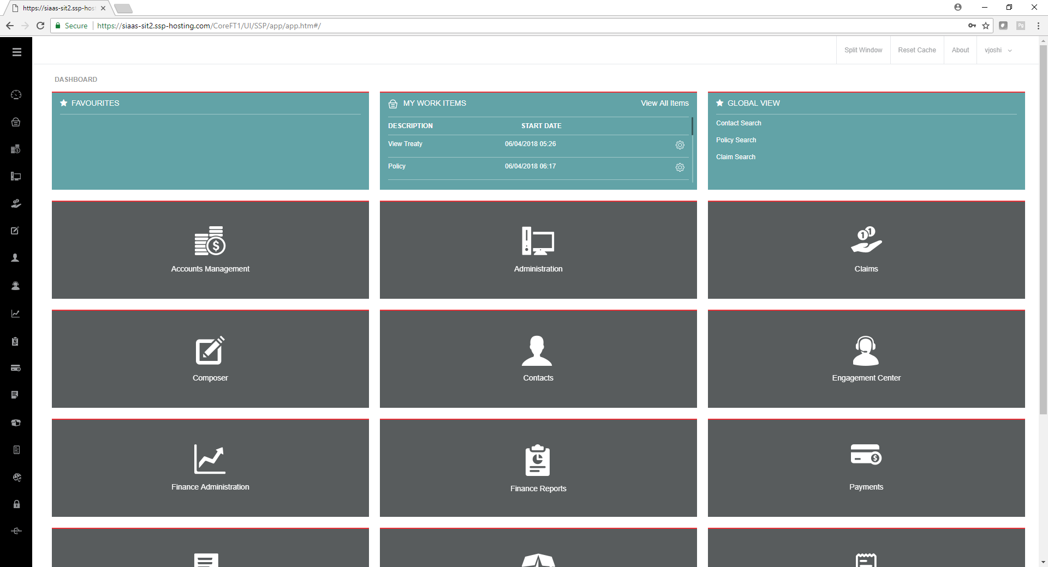

Click on Contact Search

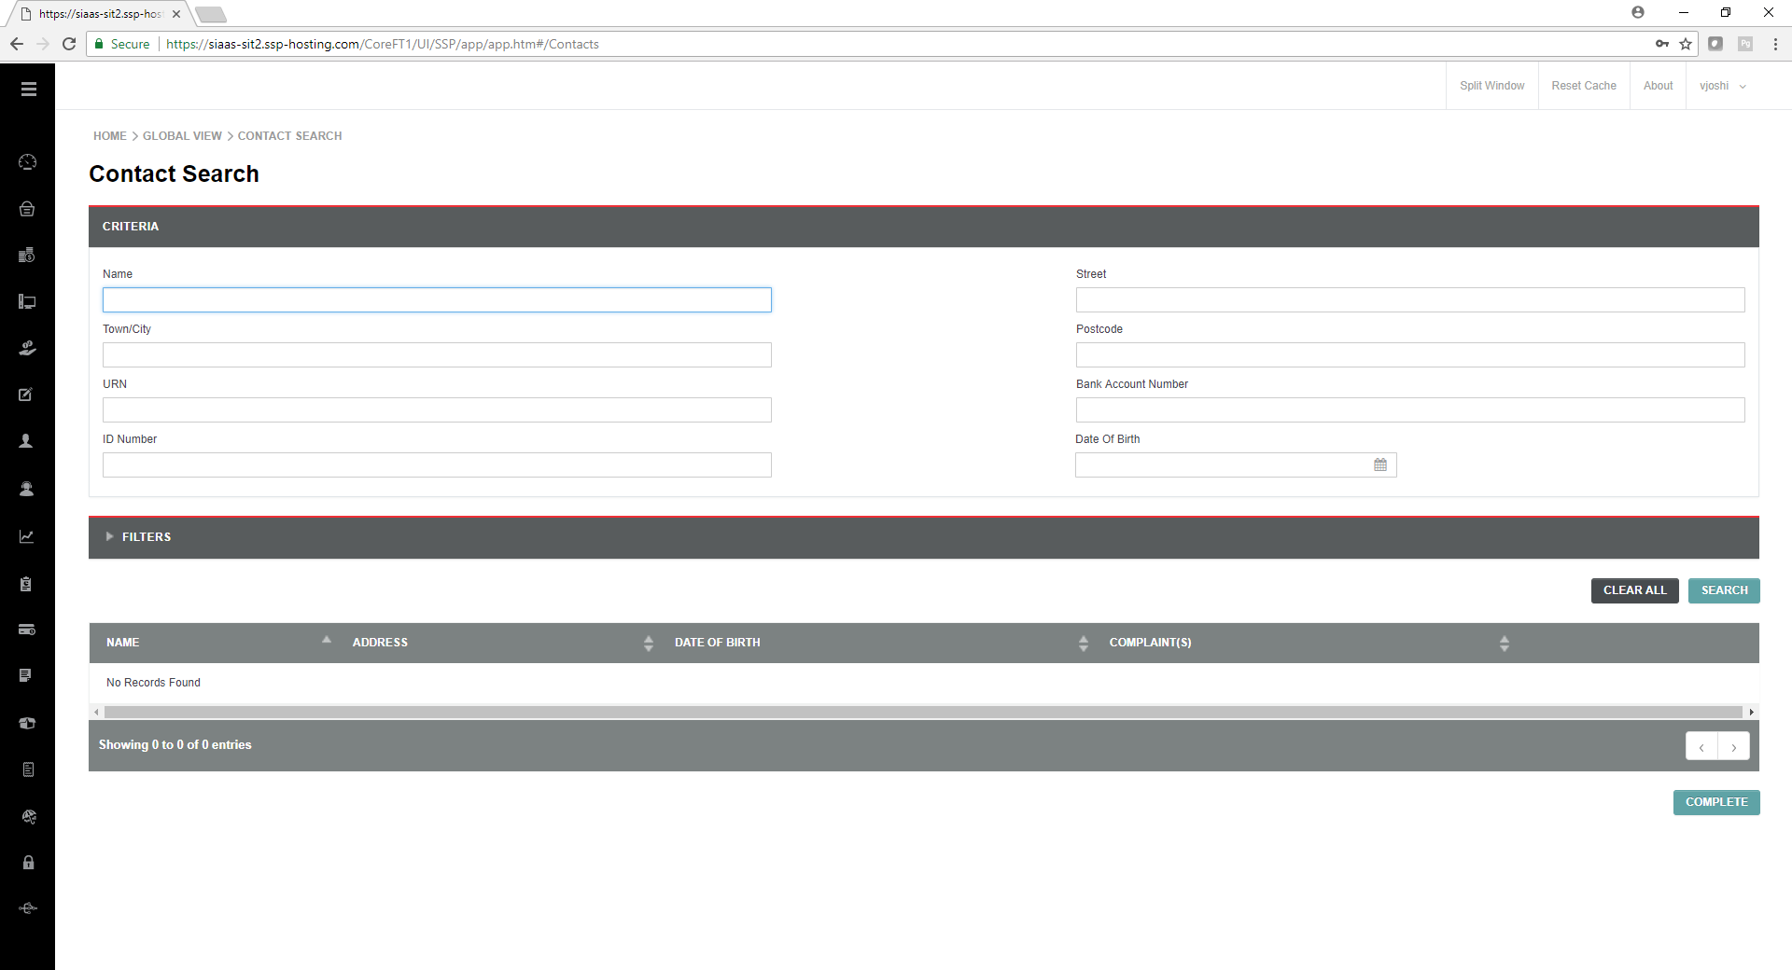

Pass

Click on Filters

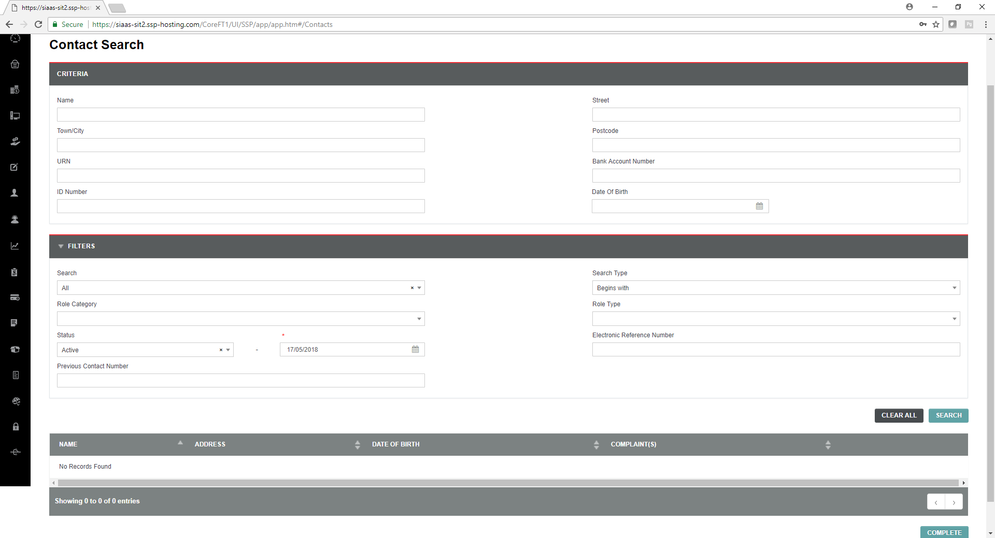

Pass – UI is as per wireframe.

TC08

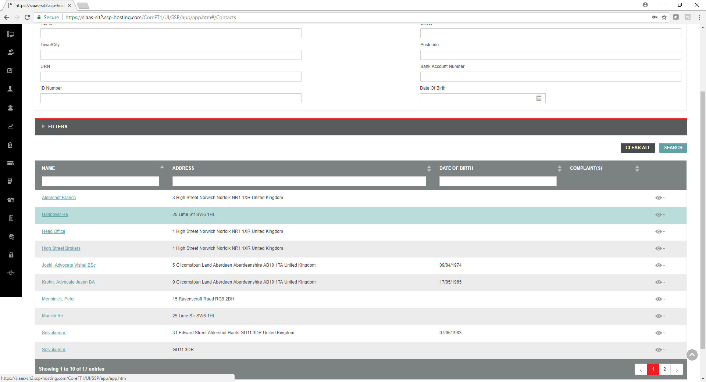

Pass

TC 9

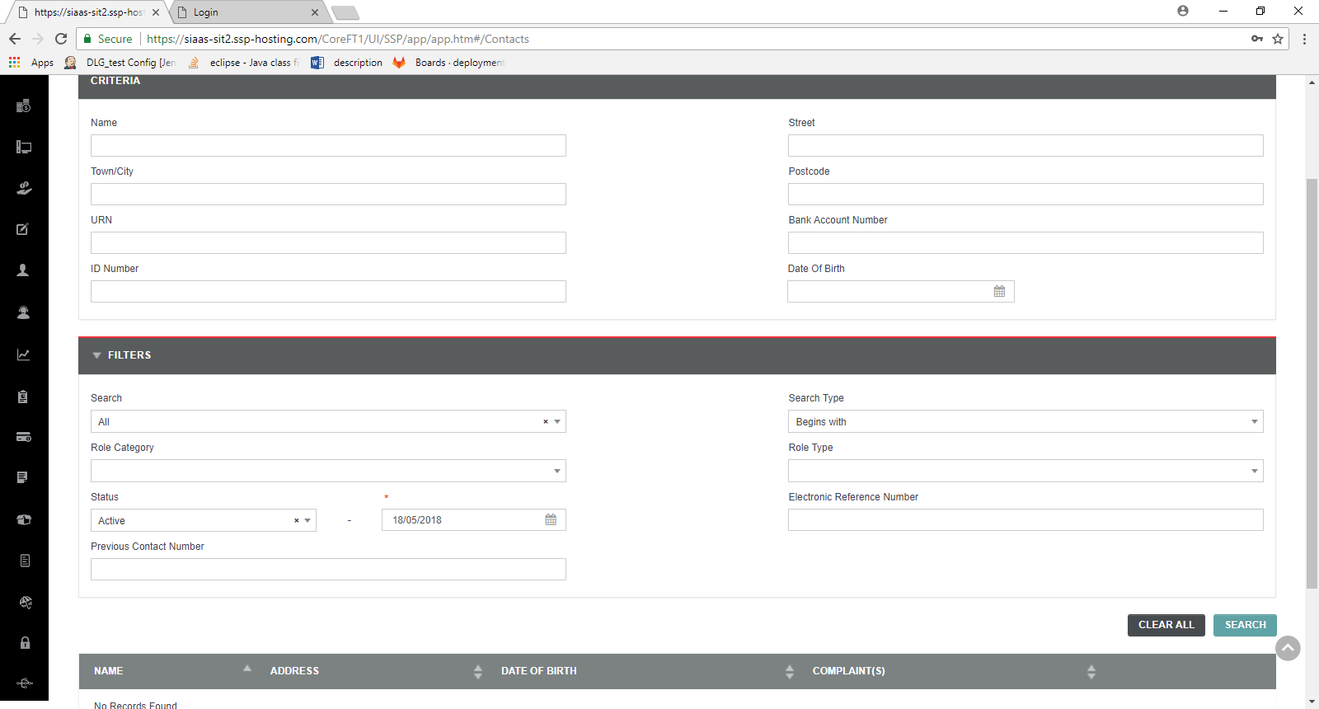

Pass

TC- 10 - Contact Search - Verify the no read only fields in filters and criteria blocks –pass

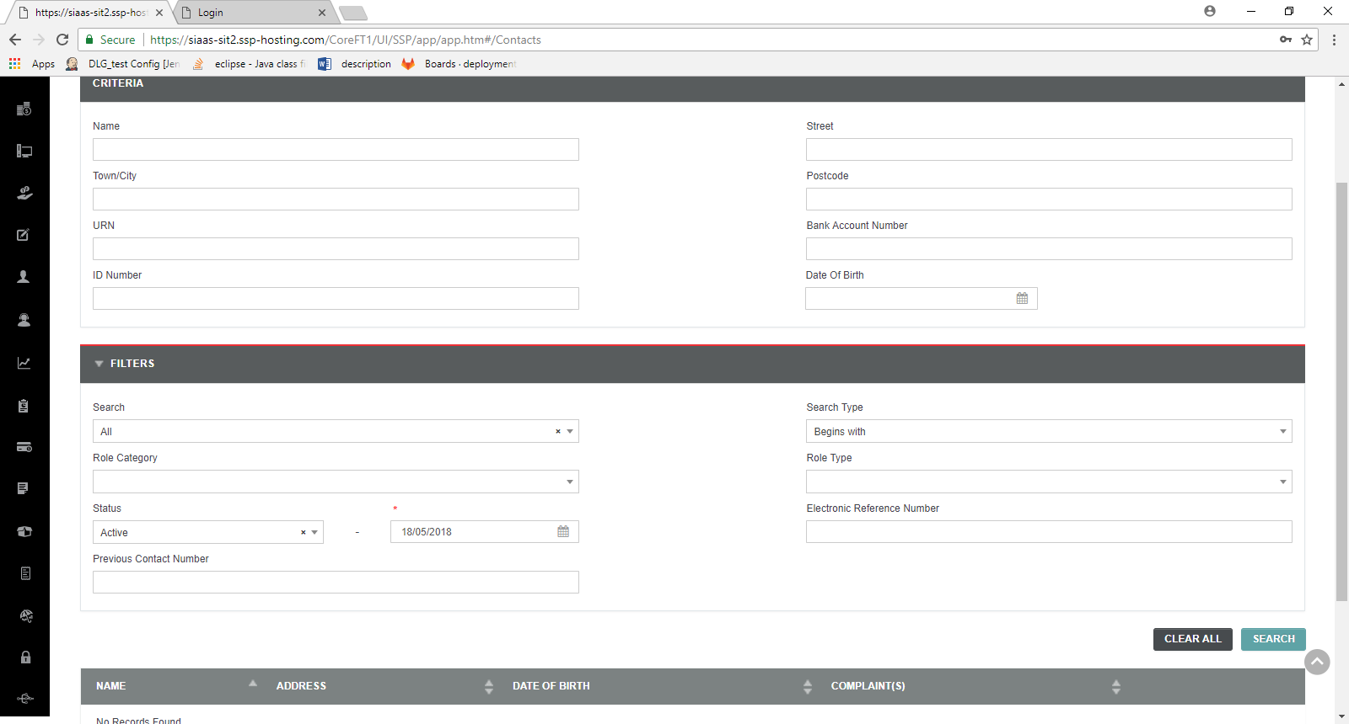

TC 11 Contact Search - Verify all Date field validation –pass

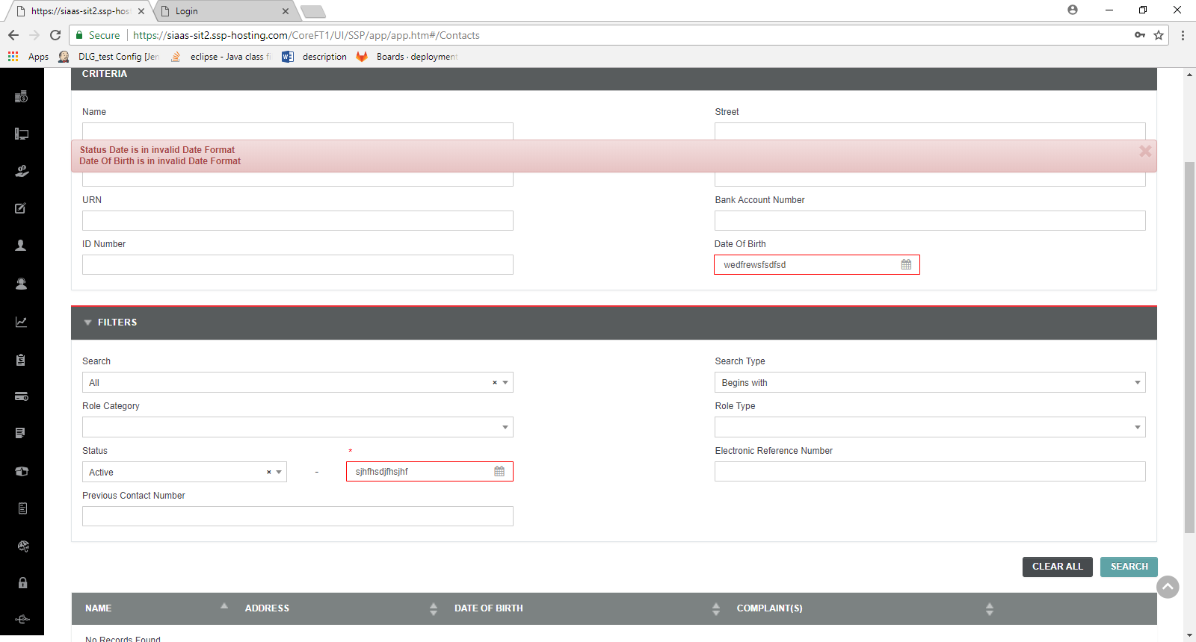

TC -12 - Verify the minimum and maximum date display in the date field calendars - Pass

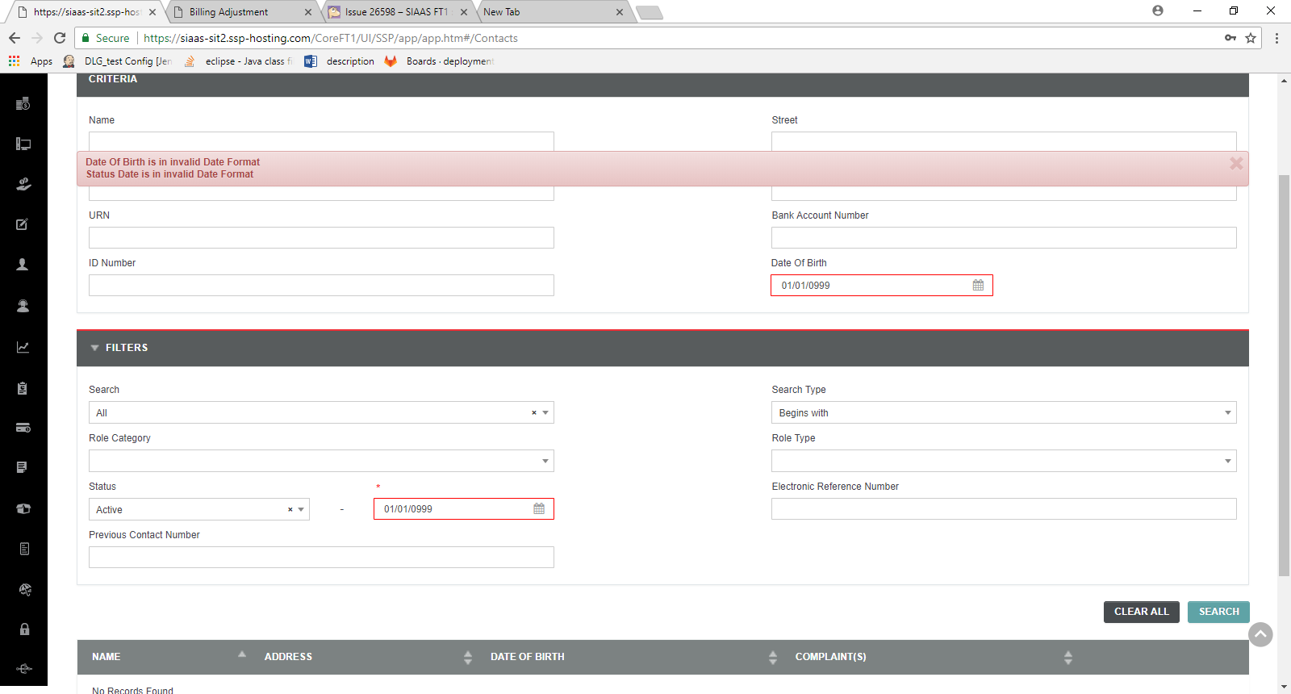 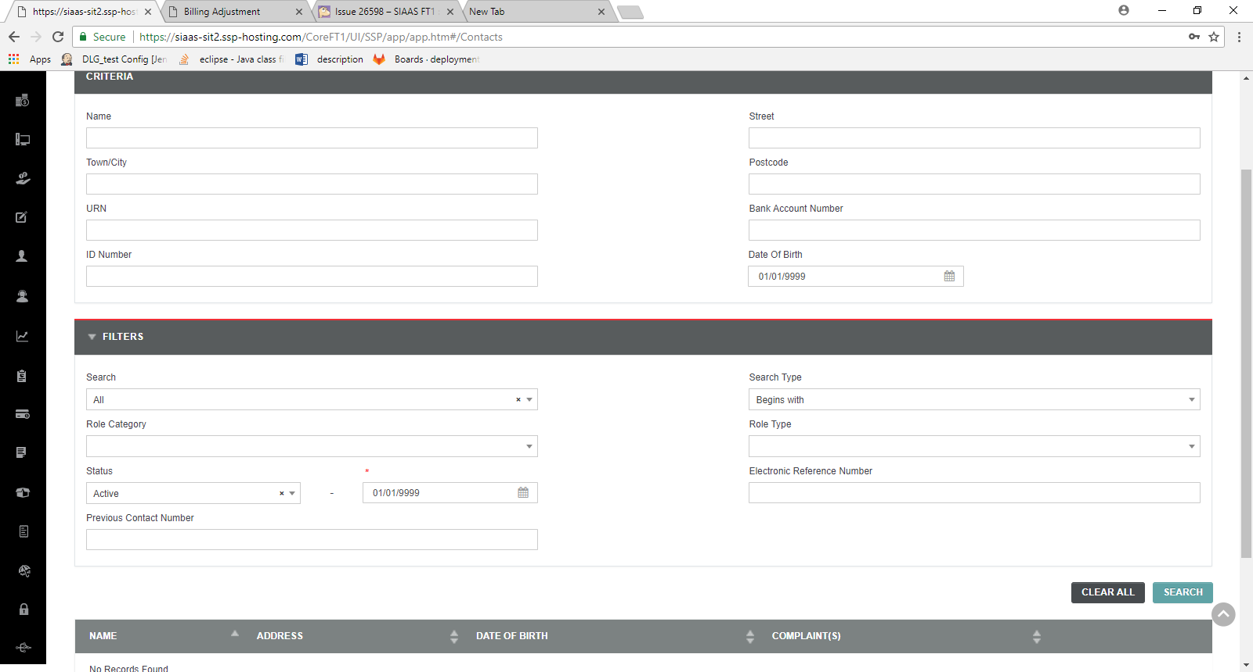 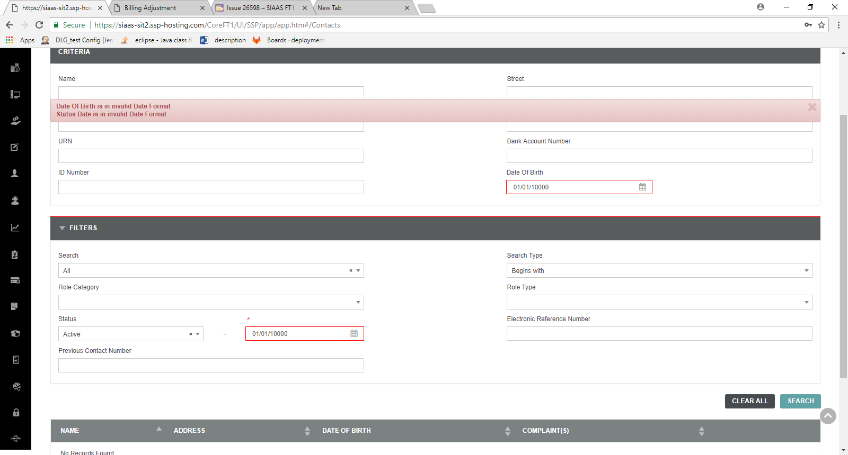

TC 13 - Verify the tab key press move cursor to next fields -Pass

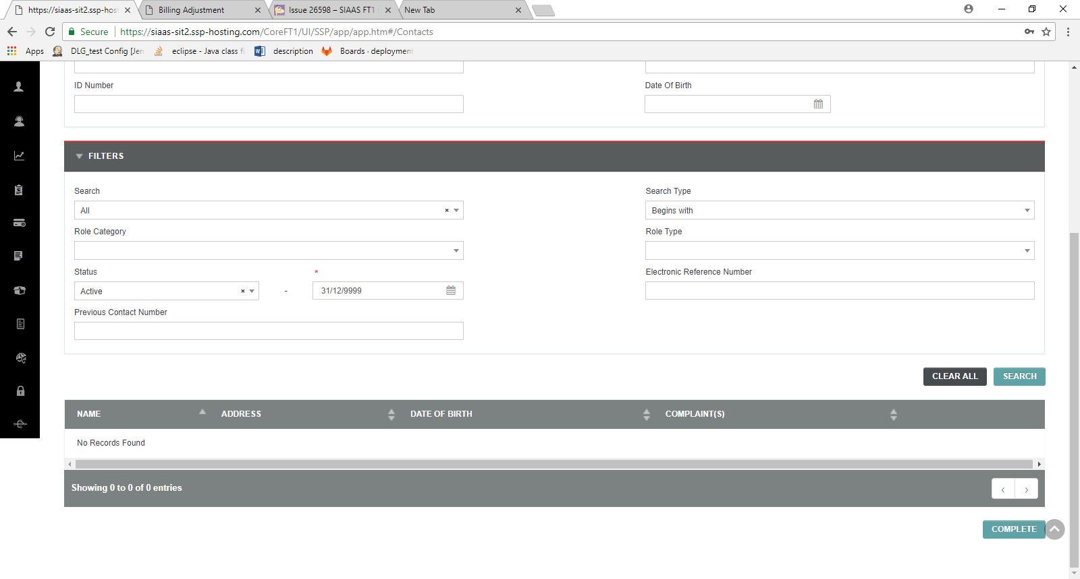

TC -14 Verify the enter key functionality- Pass

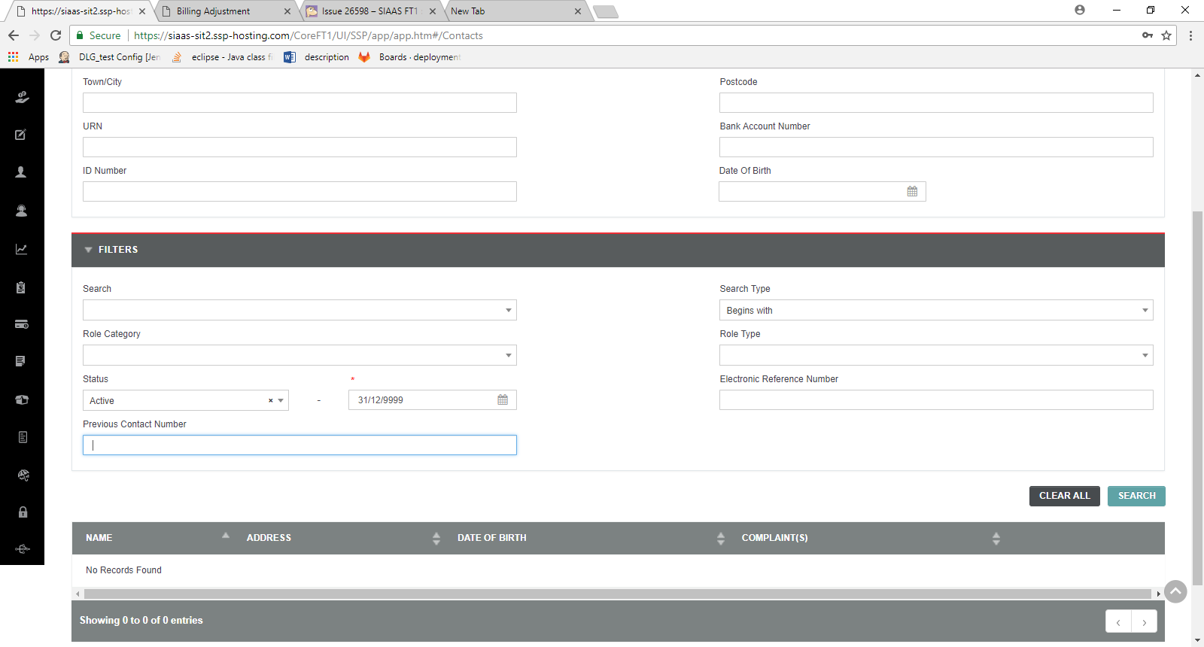 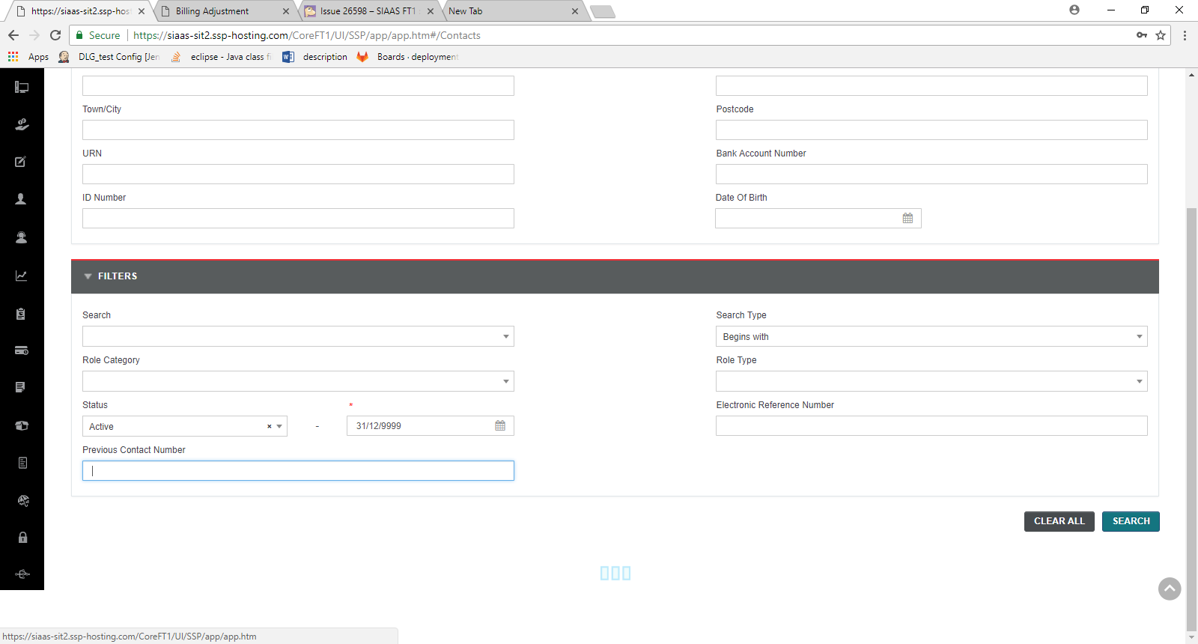 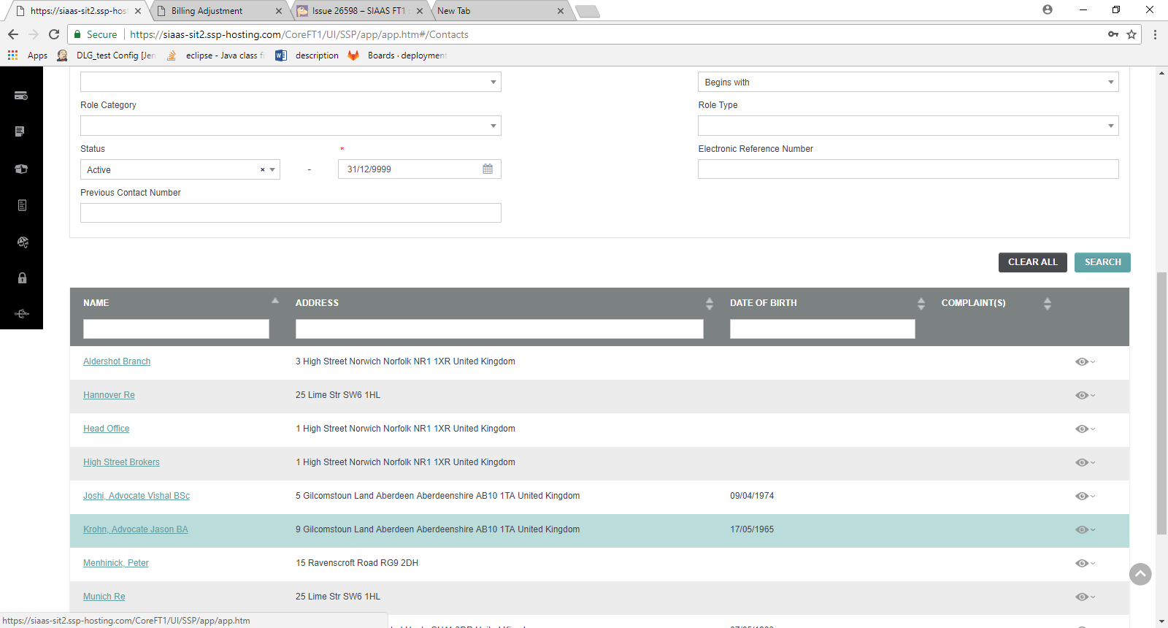

TC -15 Verify the copy and paste functionality in all pages -Pass

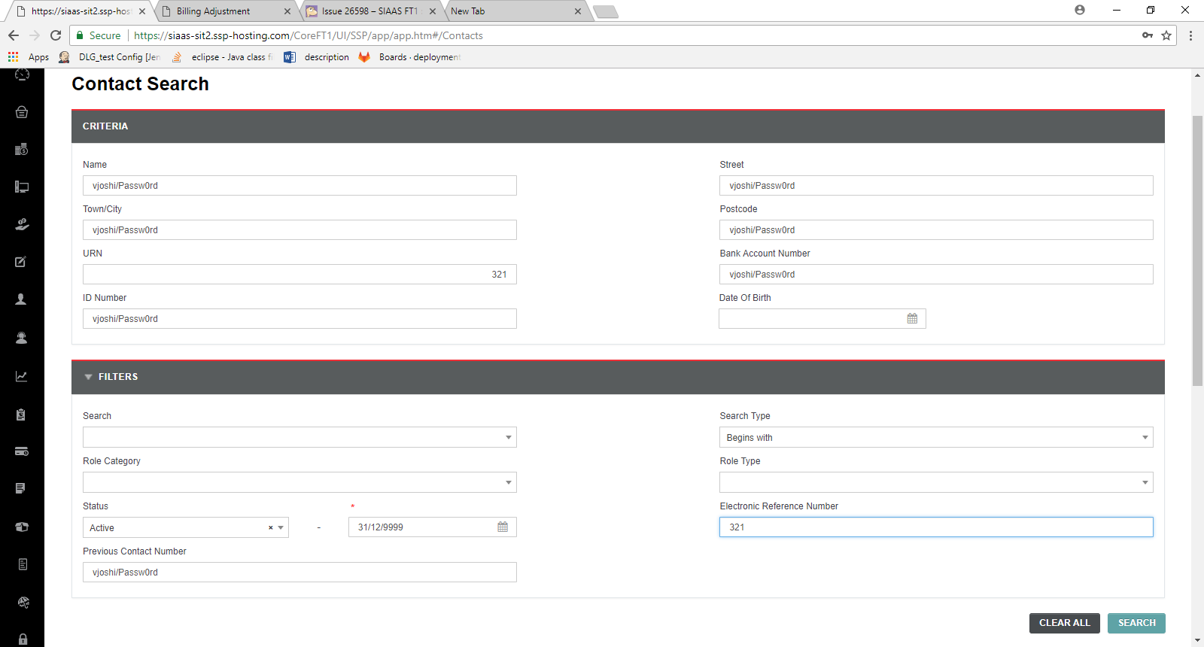

TC -16 - Verify the validation for Copy and Paste field values –Pass

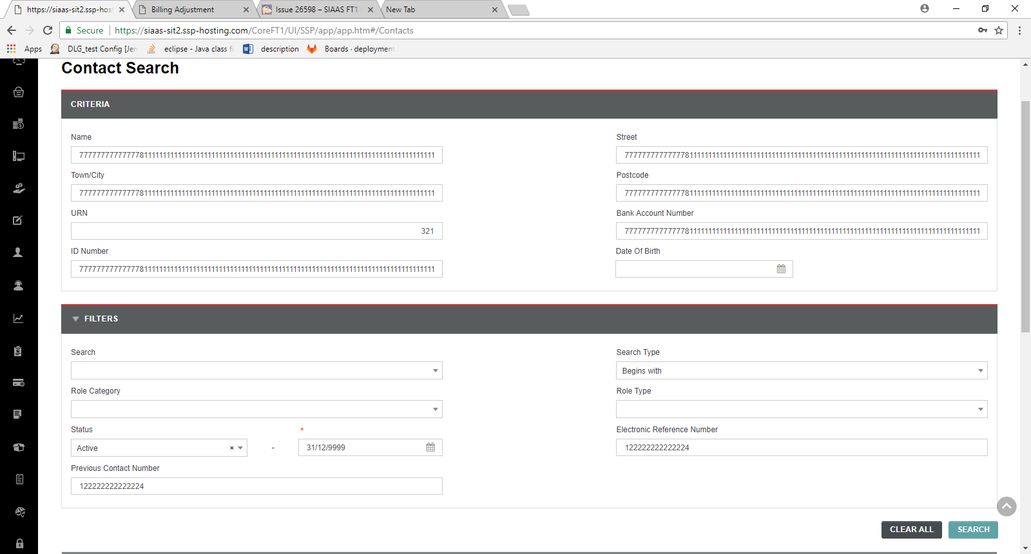

TC 17 - Verify the Tool Tip of all buttons and Icons- Pass

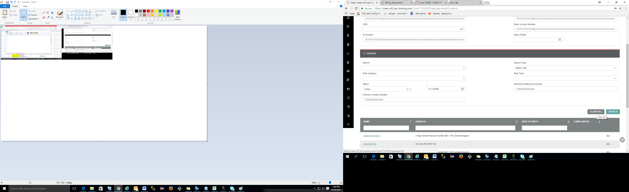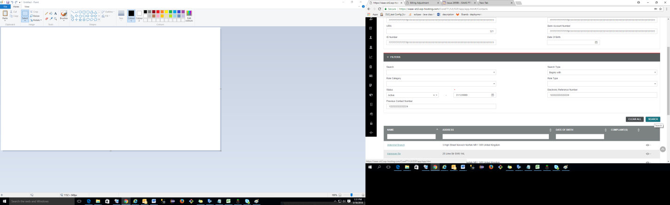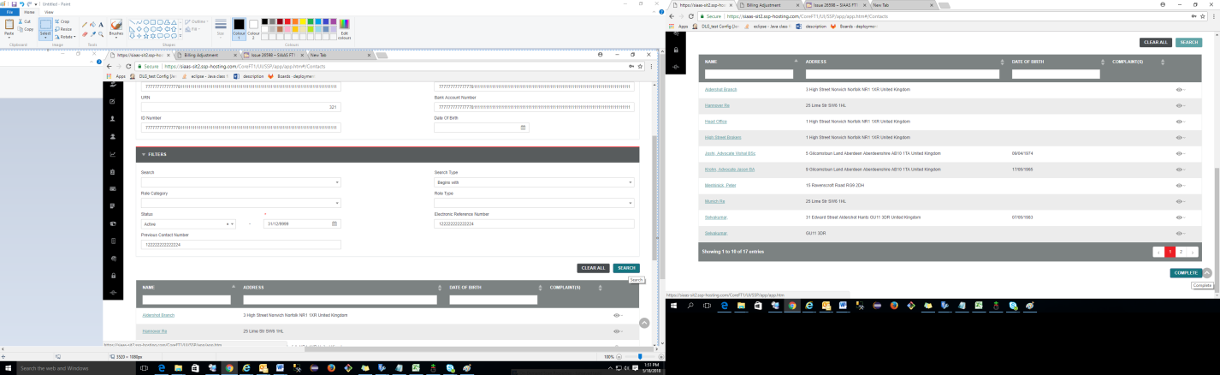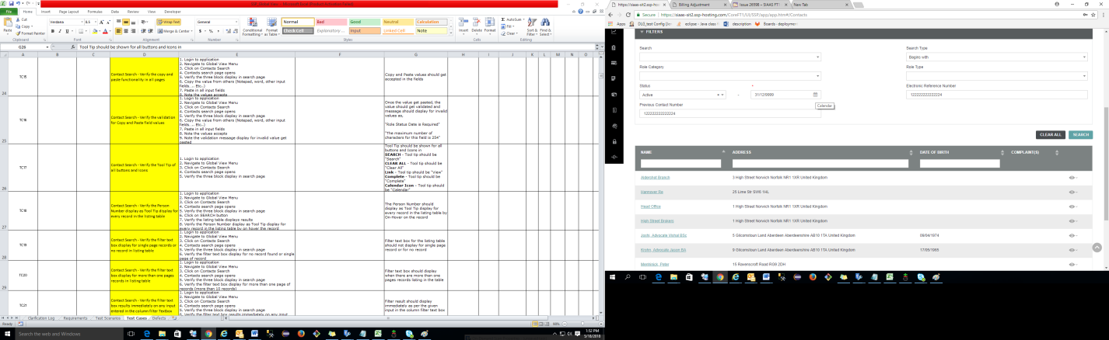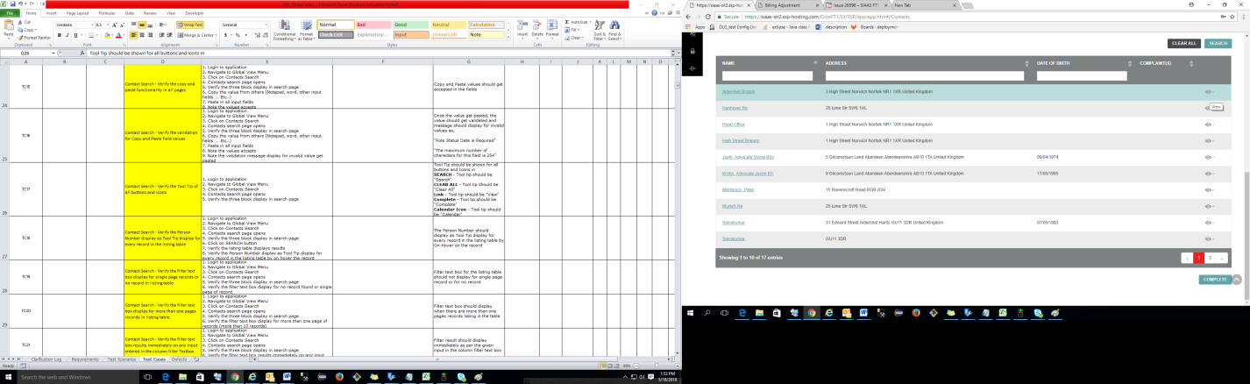

TC -18 - Verify the Person Number display as Tool Tip display for every record in the listing table -Pass

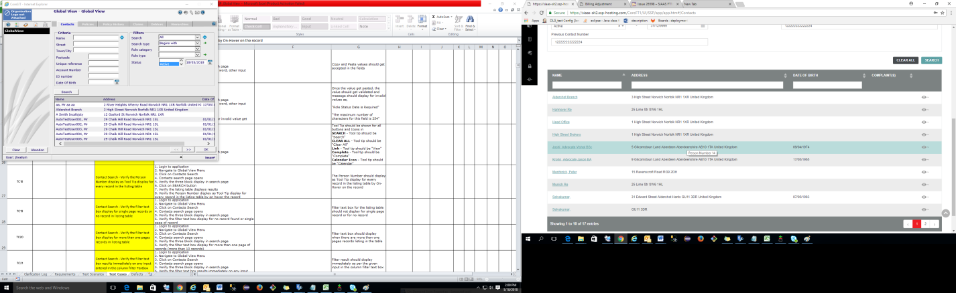

TC – 19 - Verify the filter text box display for single page records or no record in listing table -Pass

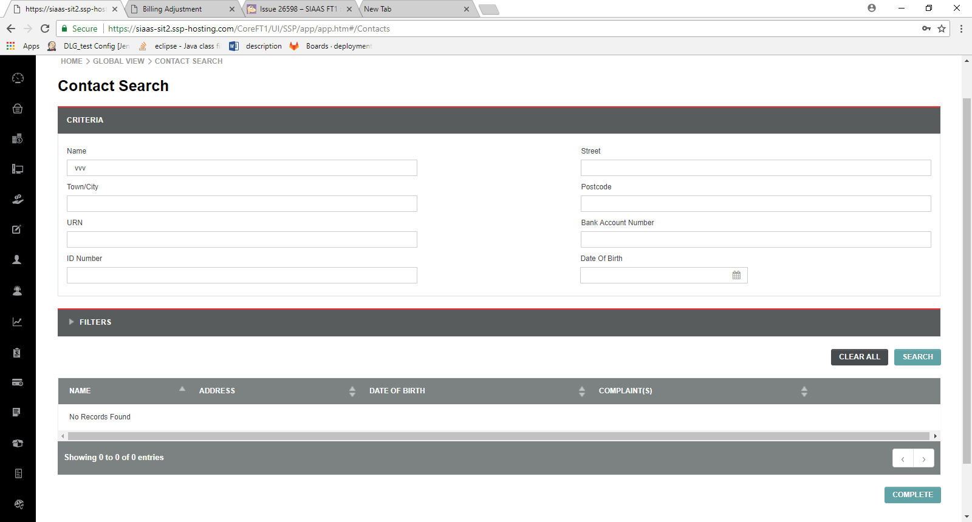

TC -20 - Verify the filter text box display for more than one pages records in listing table - pass

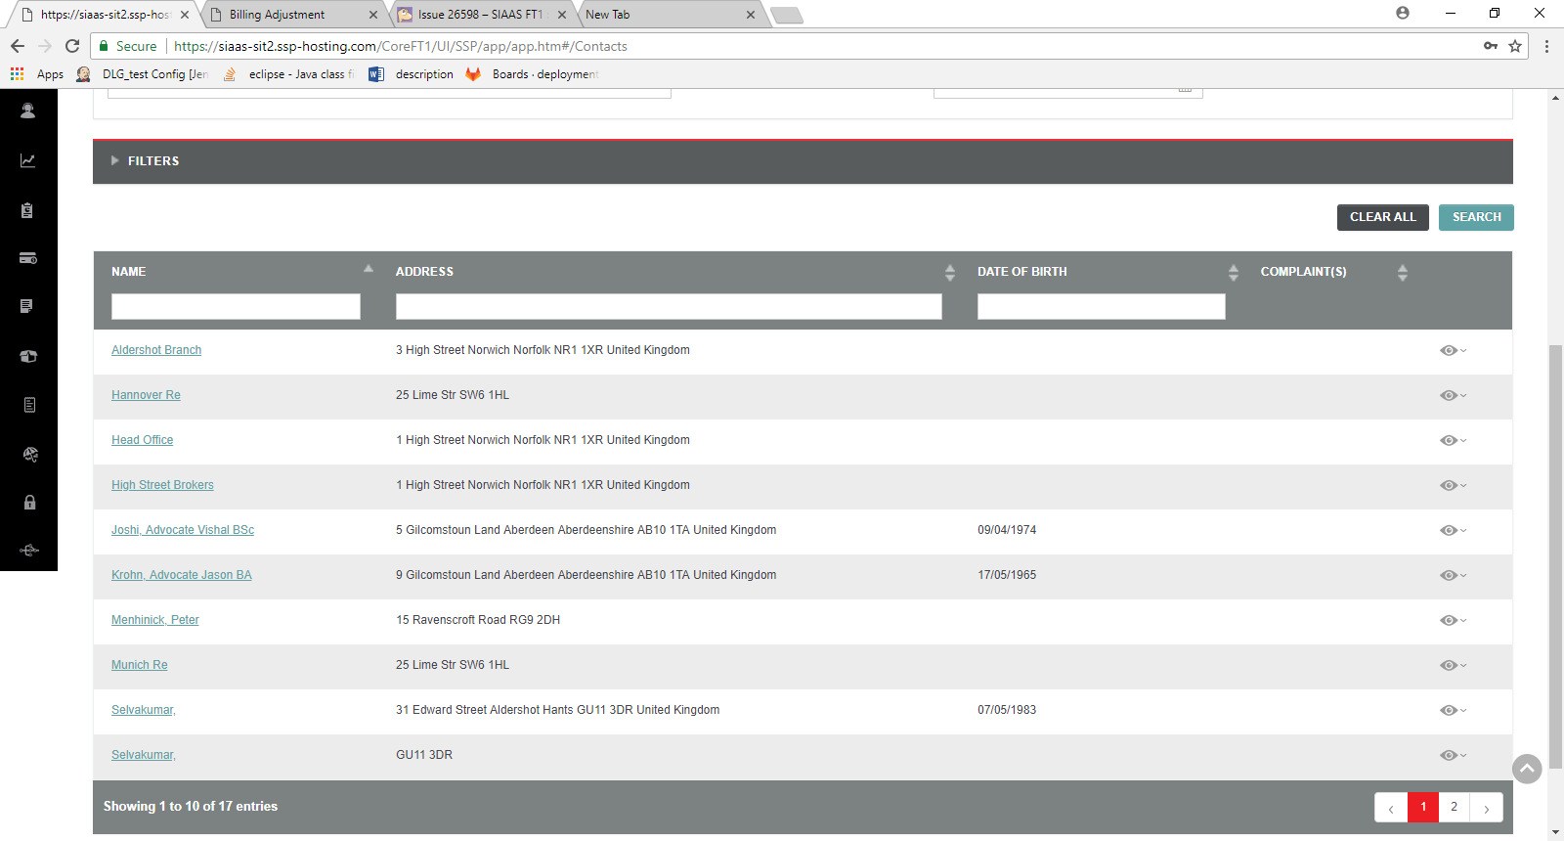

TC -21 Verify the filter text box results immediately on any input entered in the column filter Textbox –Pass

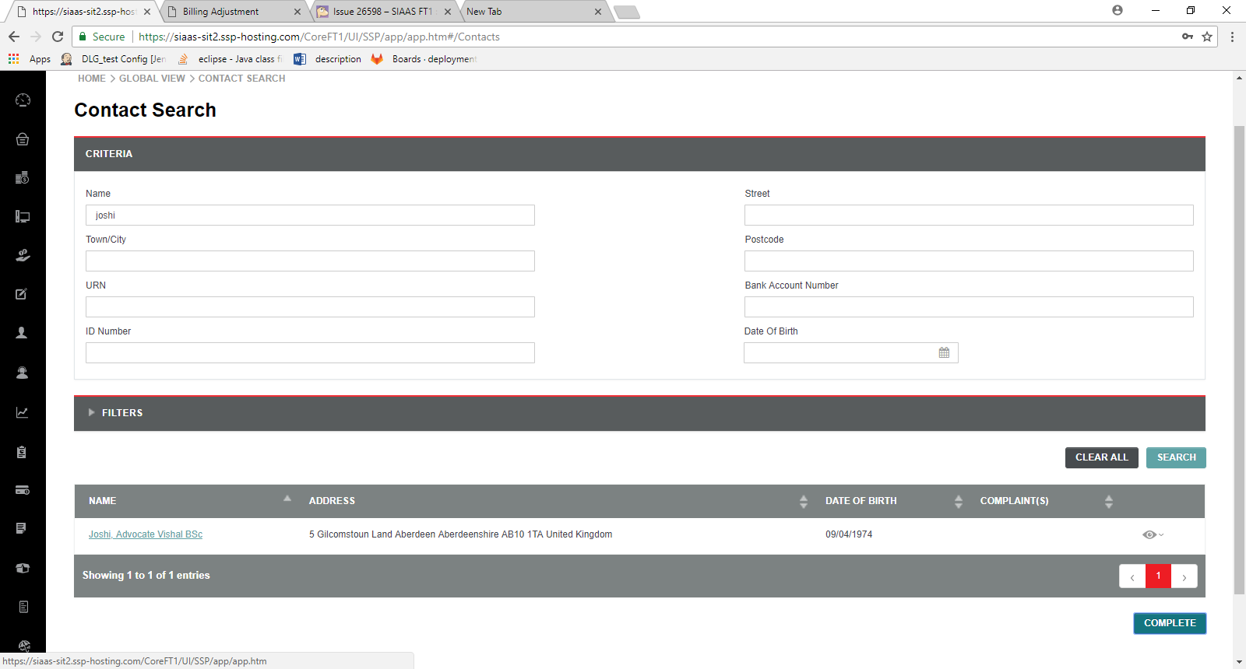

TC – 22 Verify the sorting order in the listing table

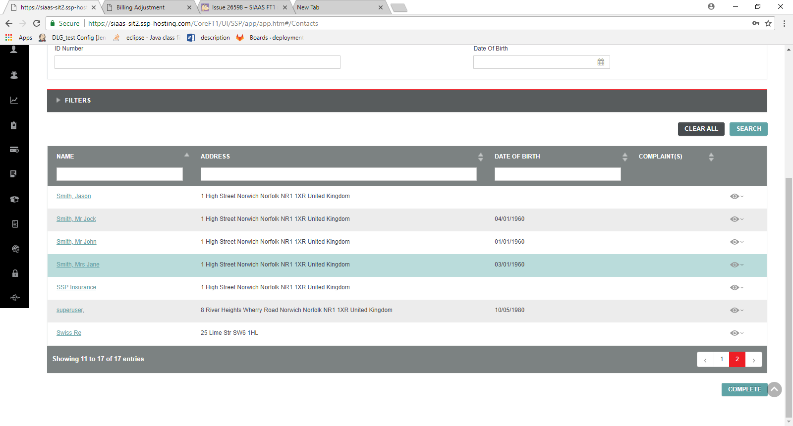

TC – 23 Verify Sorting icons and result –Pass

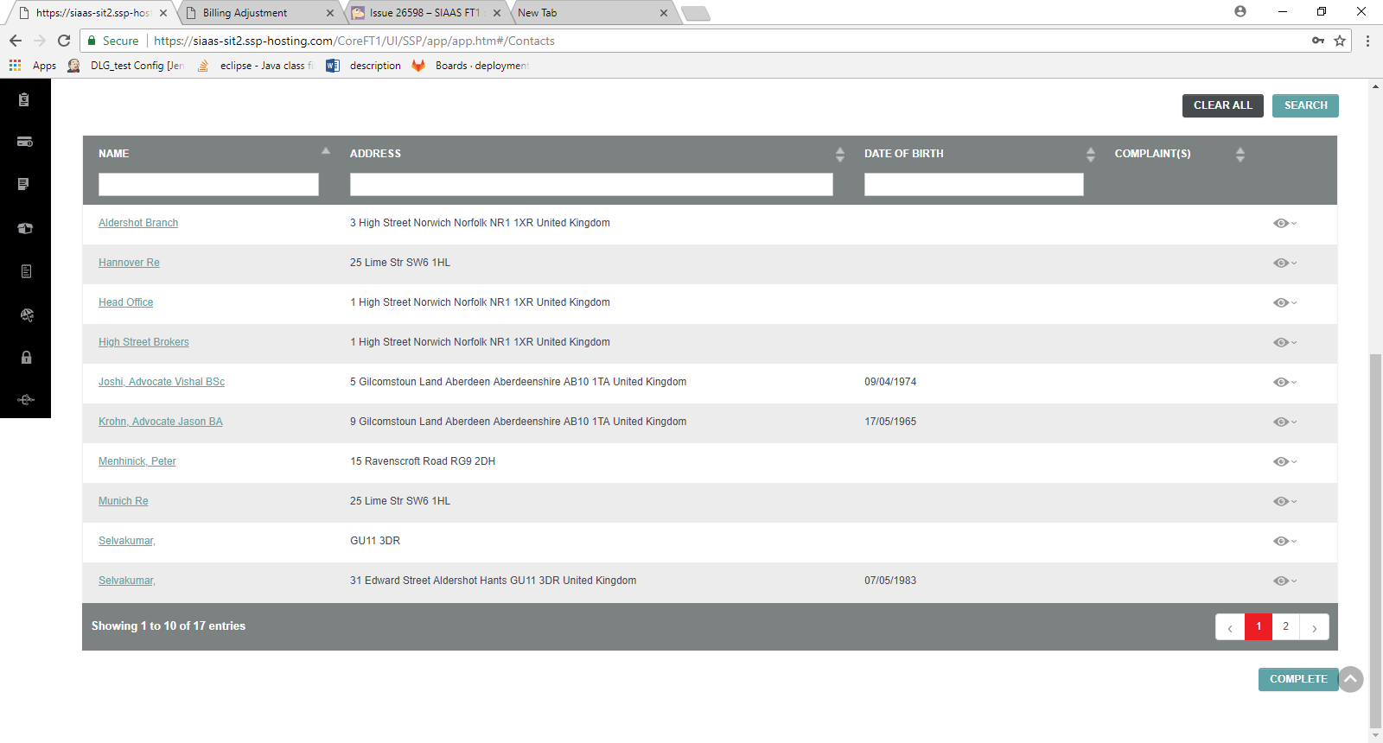

TC -24 - Verify the search result output when no records displayed -Pass

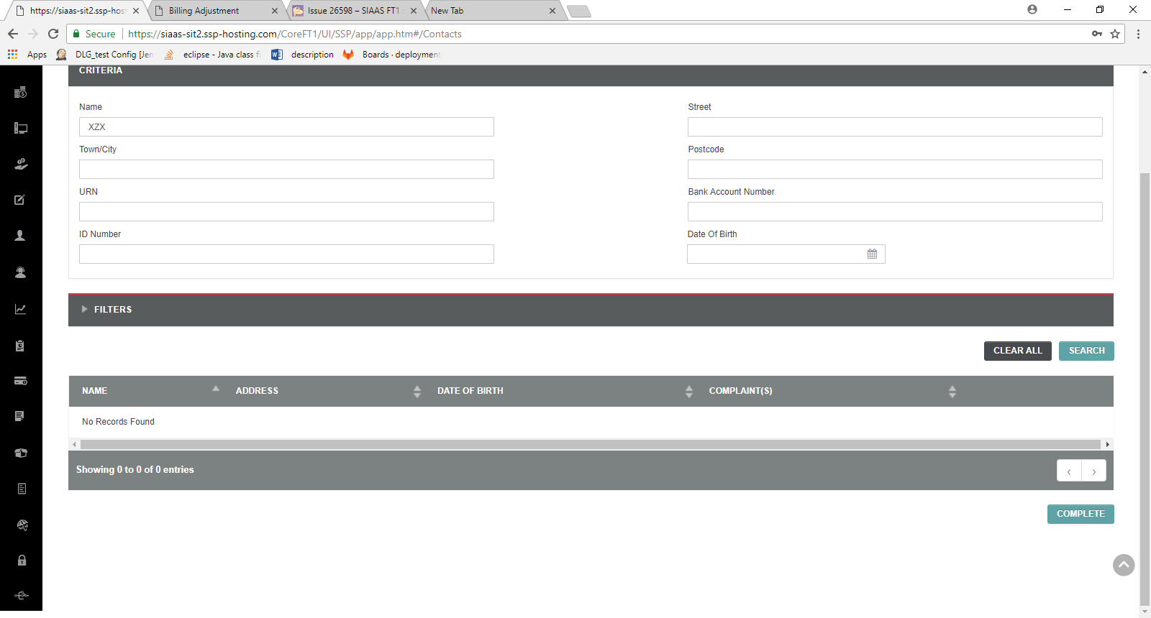

TC – 25 Verify the search result count in the listing table –Pass

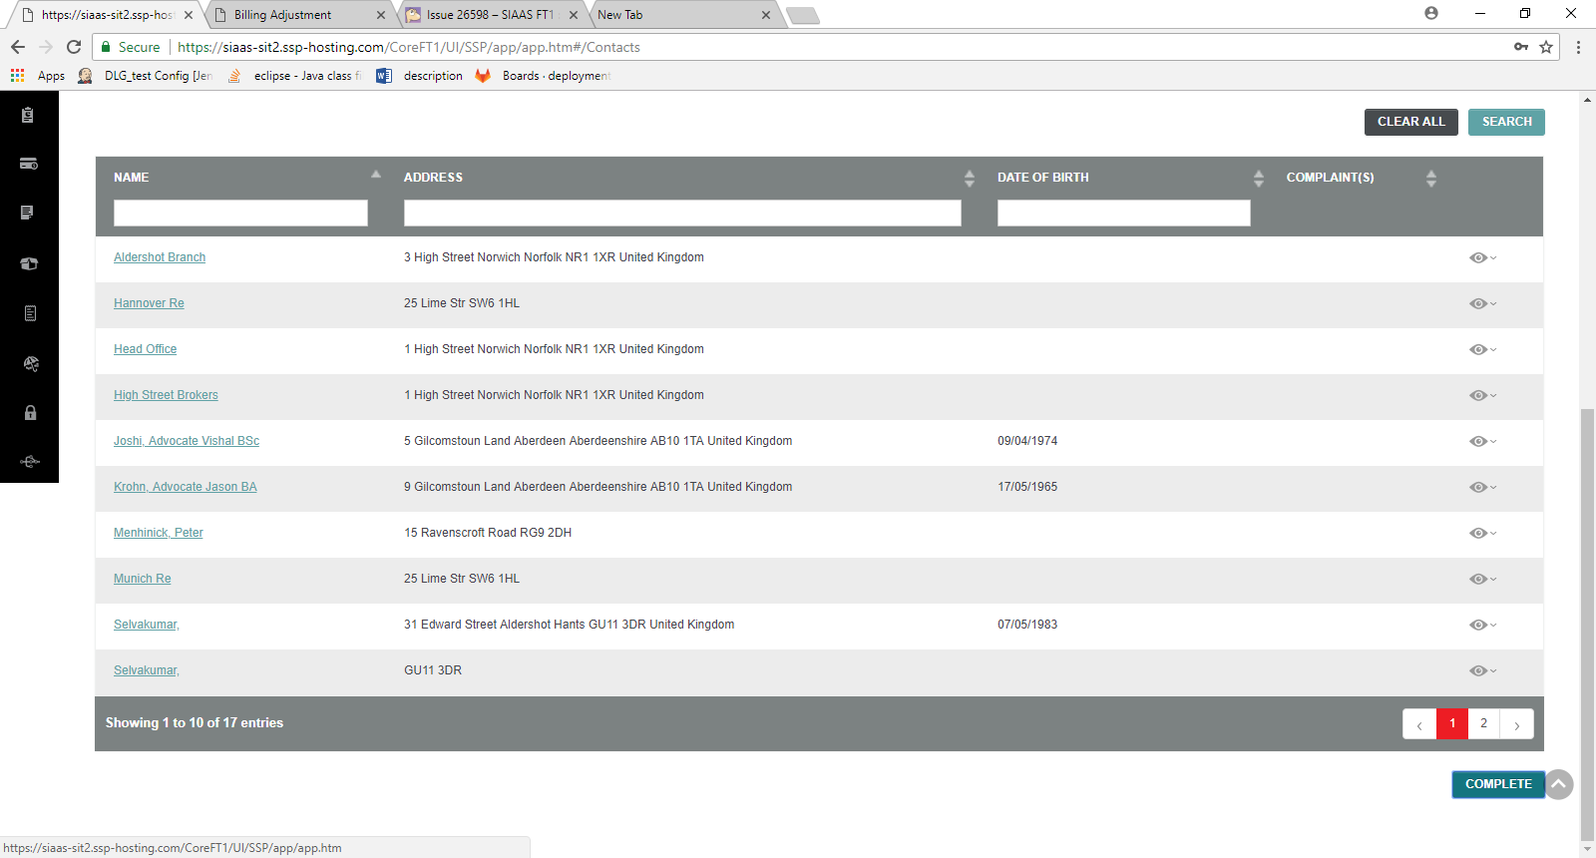

TC -26 - Verify the Pagination page number takes to corresponding page – Pass

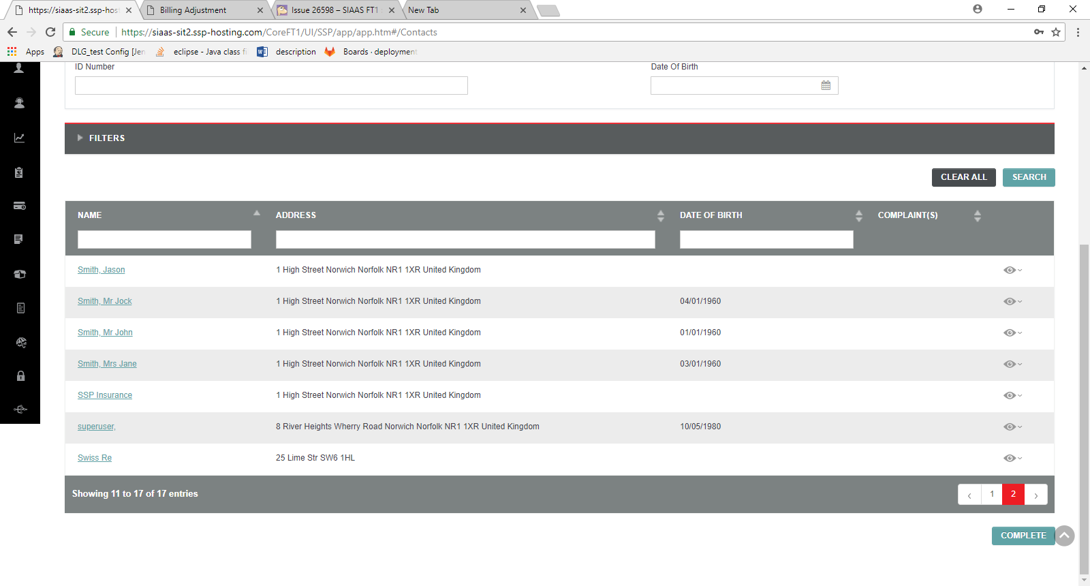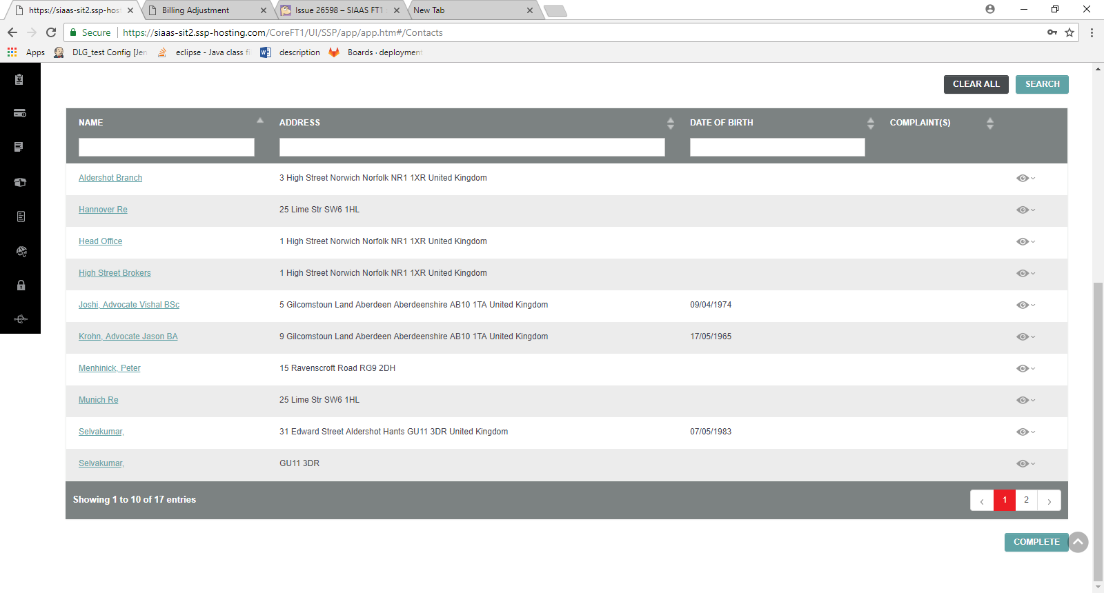

TC -27 - Verify the "Previous/Next" button are de-active in first and last page

Next button :



Previous button

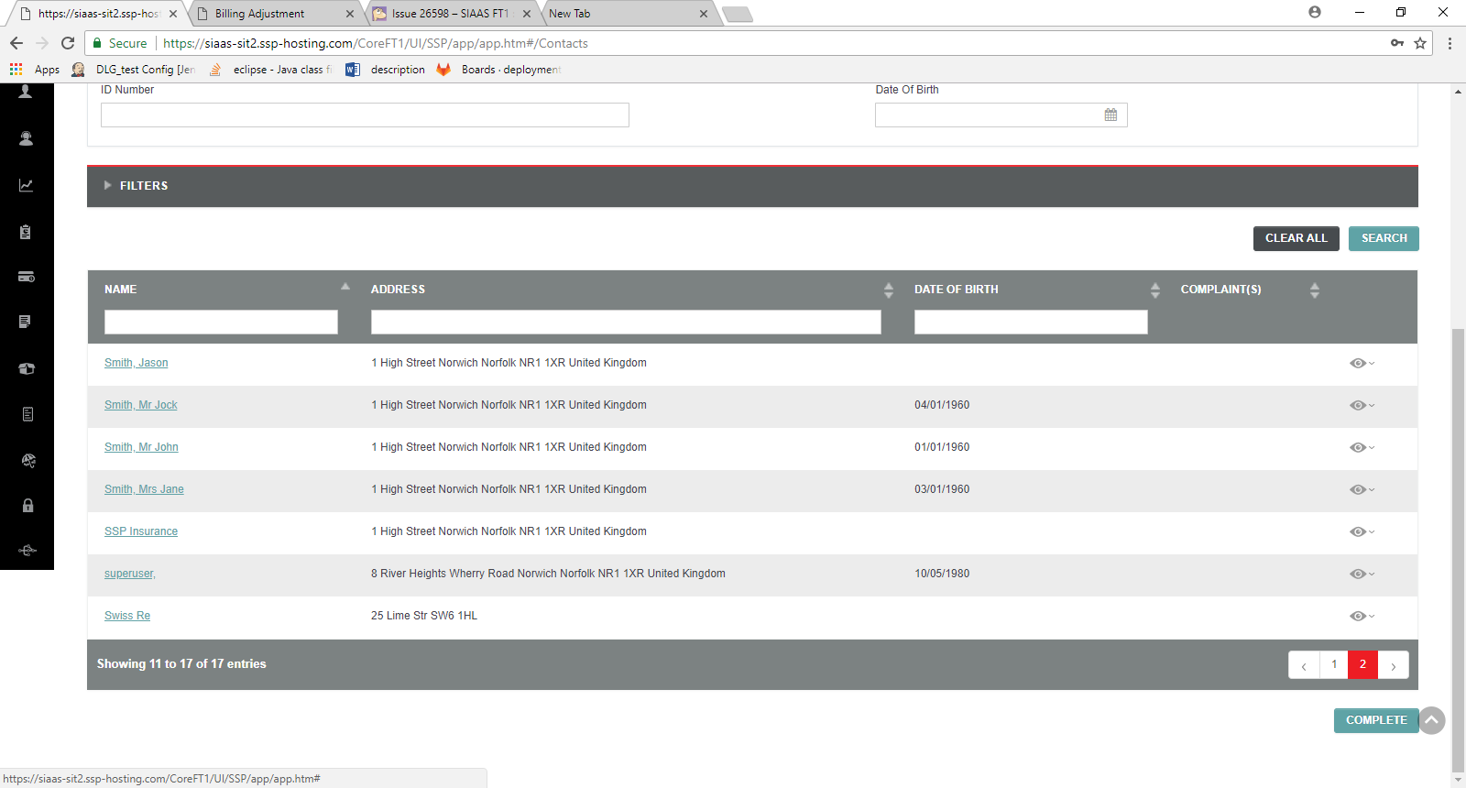

TC -28 - Verify the fields maximum character length for the fields in the criteria and filter blocks –Pass

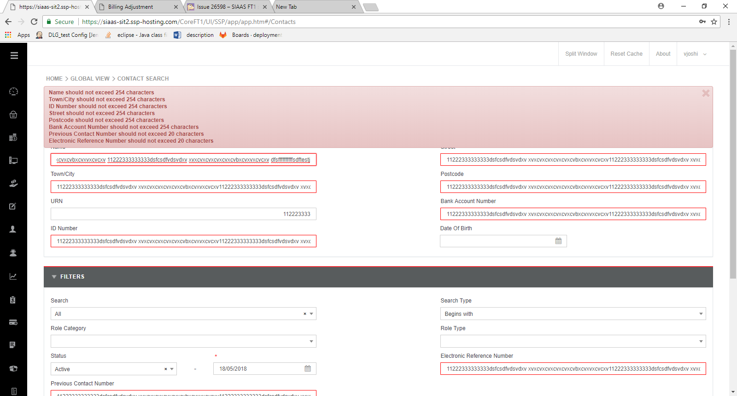

TC -29 - Verify the search functionality without any criteria given except default values

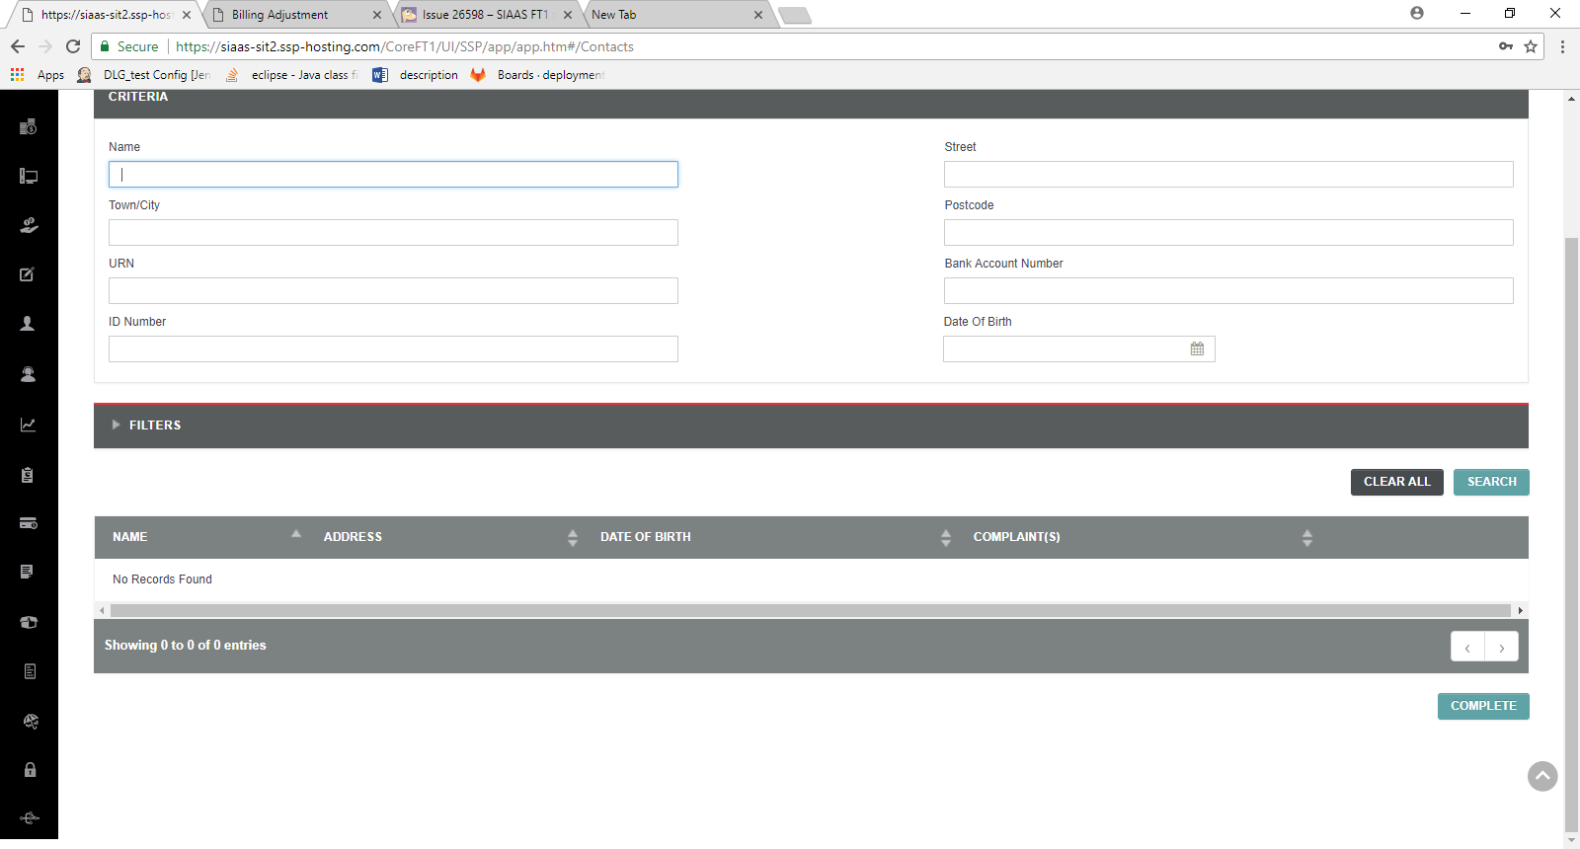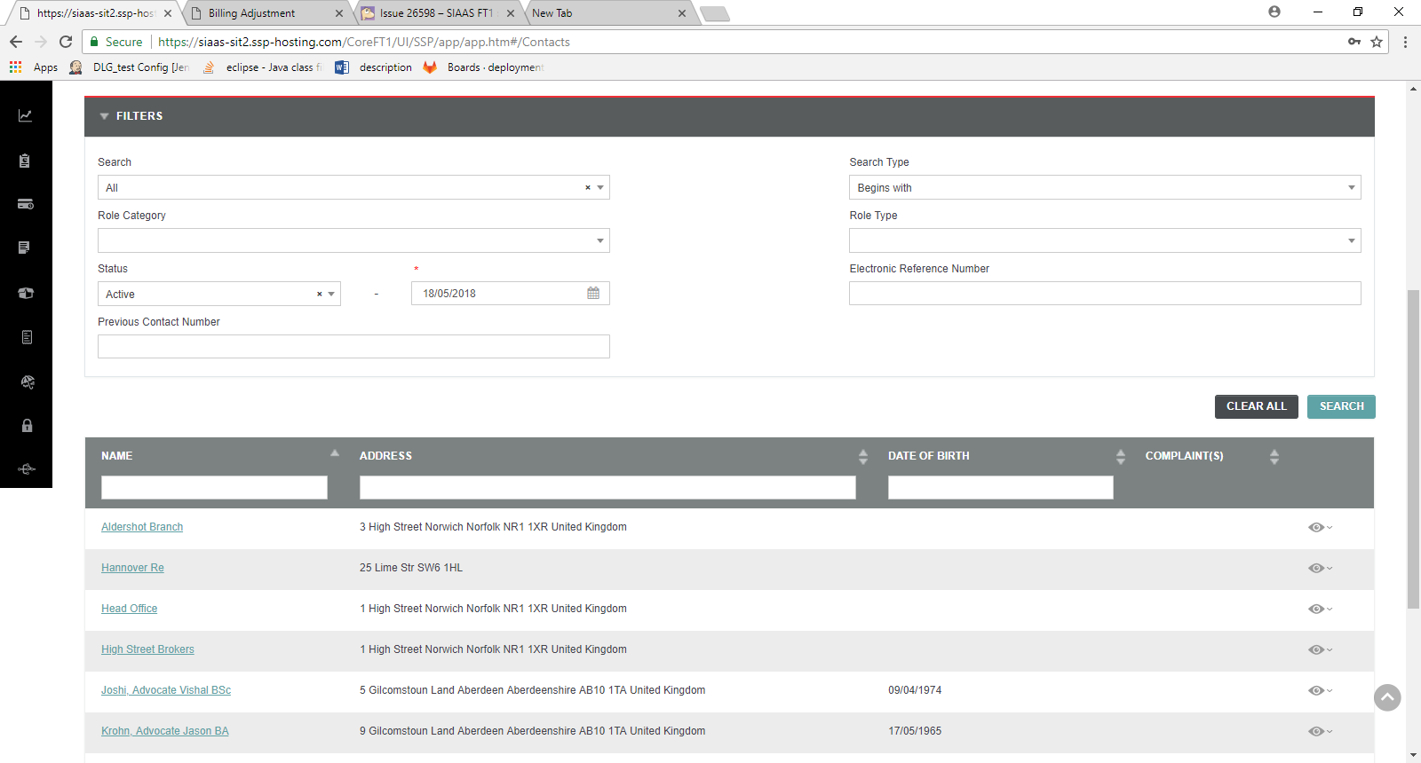

TC -30 Verify the search functionality with criteria inputs

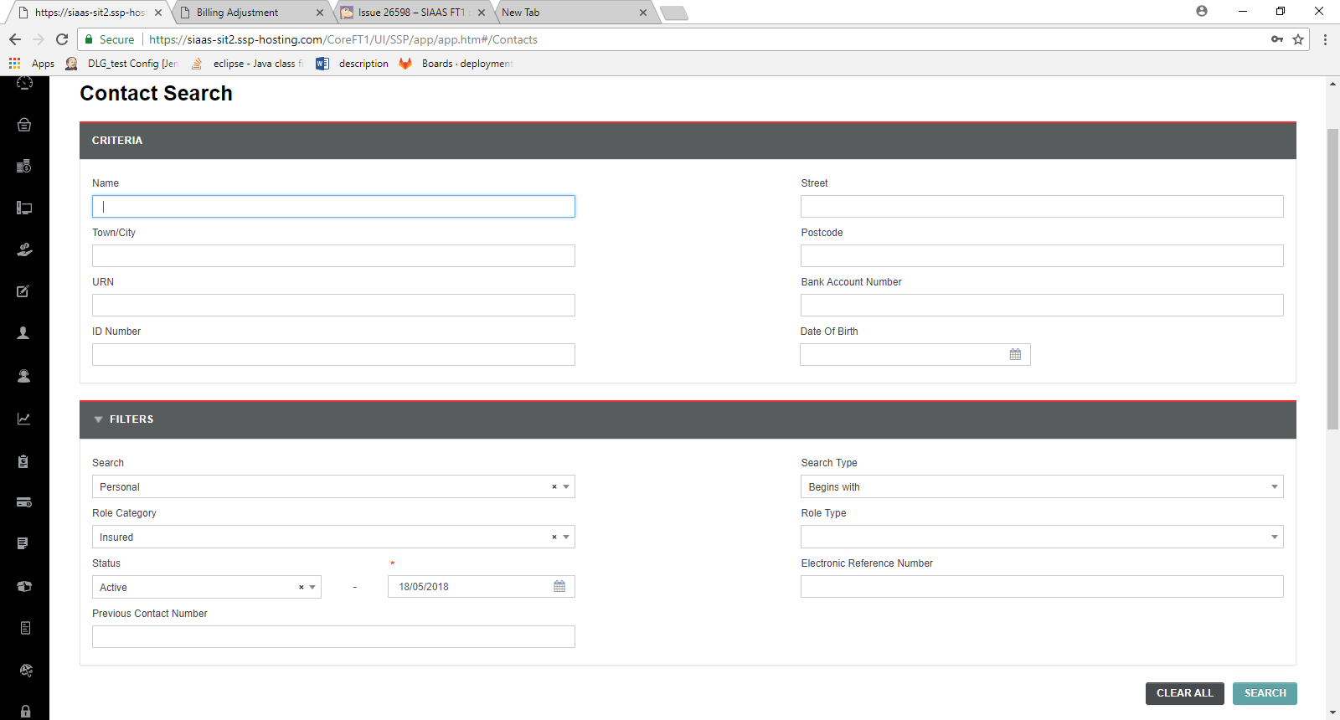

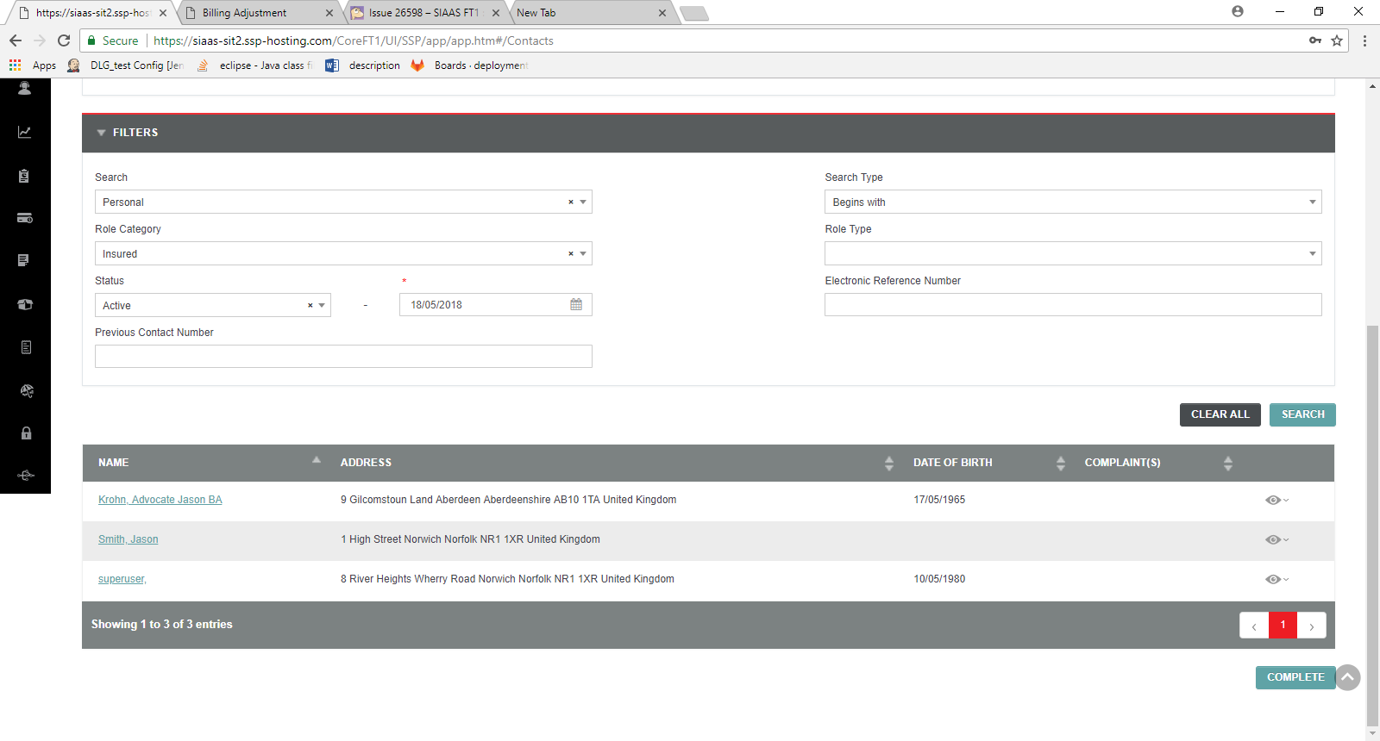

TC -31 - Verify the search functionality is working for the criteria with case sensitive -Pass

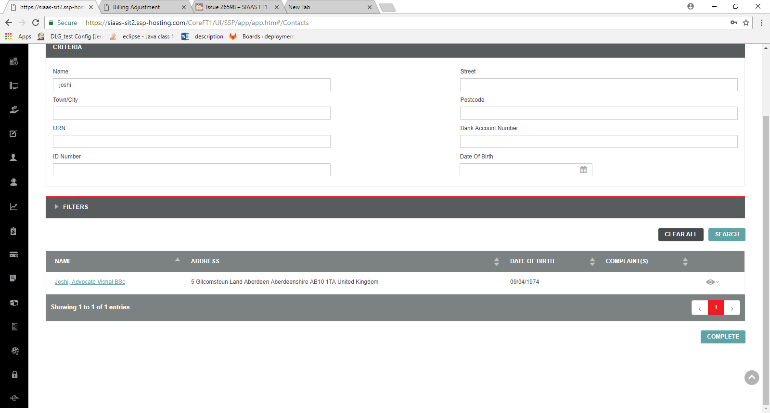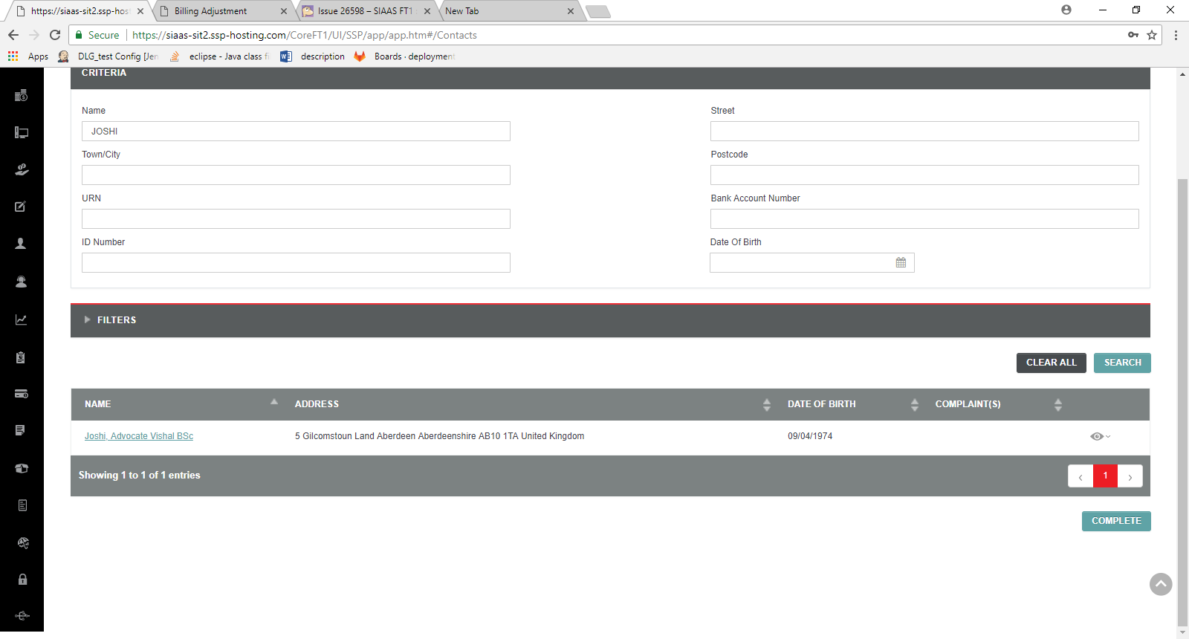

TC -32 Verify "Clear All" button placement -Pass



TC – 33 - Verify "Clear All" functionality is working -Pass

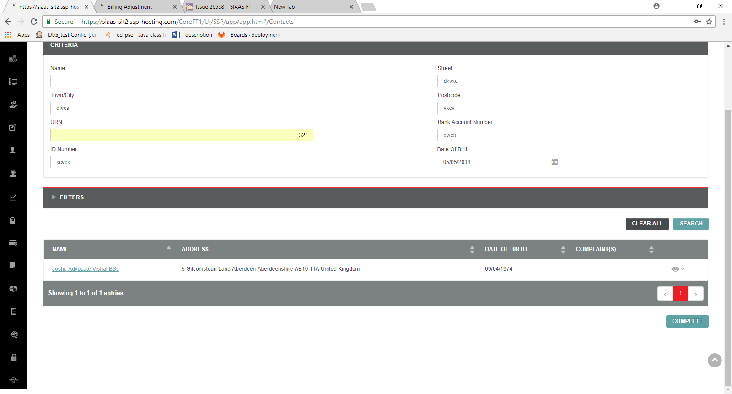

Click Clear all

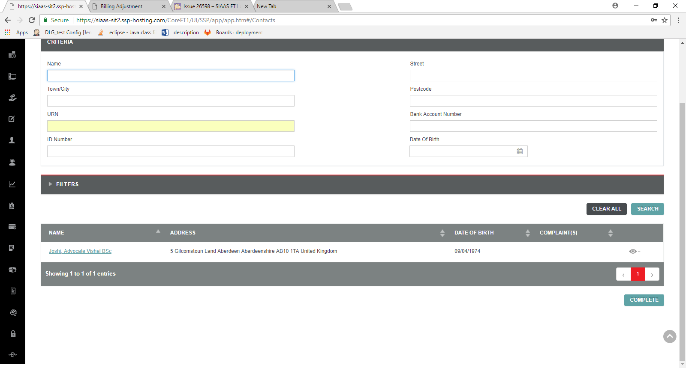

TC 34 - Verify the data listing are same in both Select and UI Refresh application – blocked for now

Tc – 35 Verify the Person Number details display for Personal contacts and Company Number details display for Corporate contacts for every record on-hover in the listing table –Pass

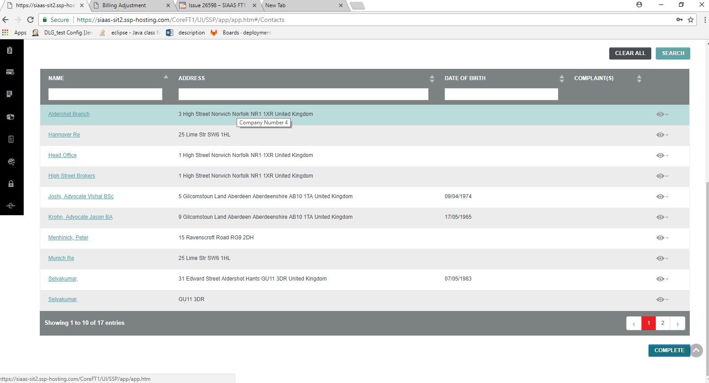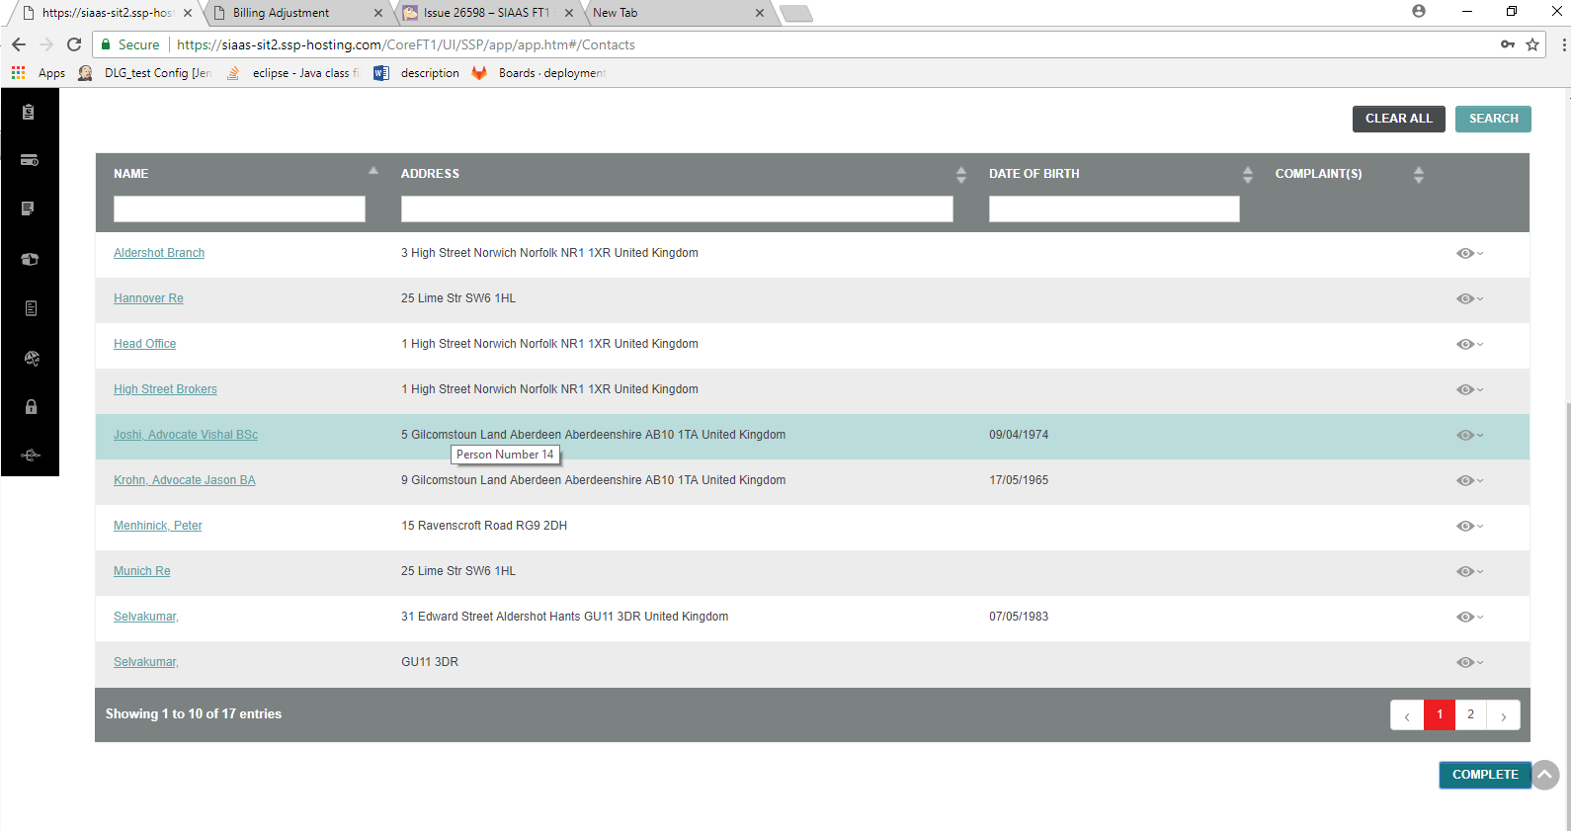

TC -36 - Verify the Search dropdown list –

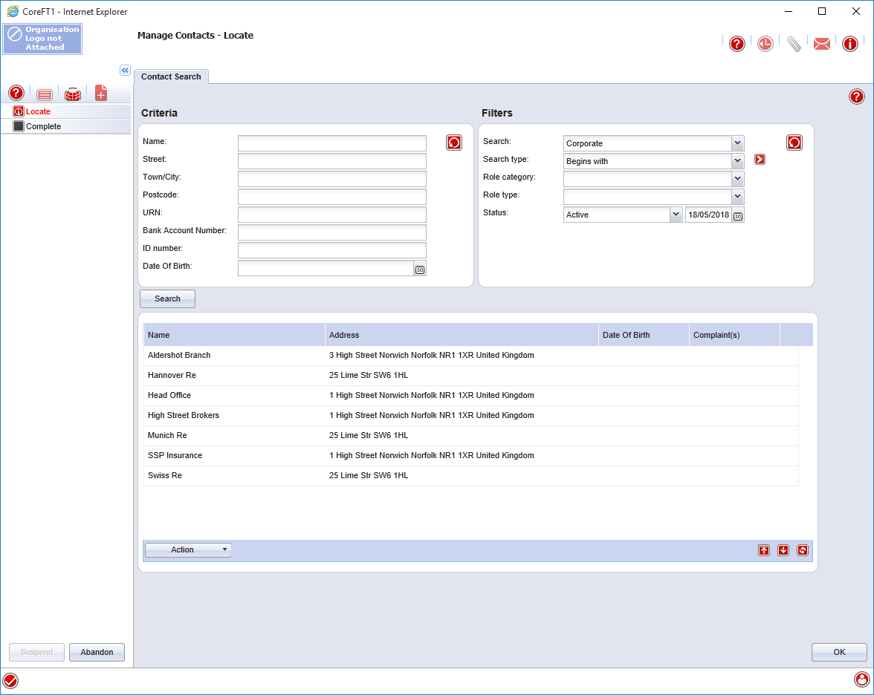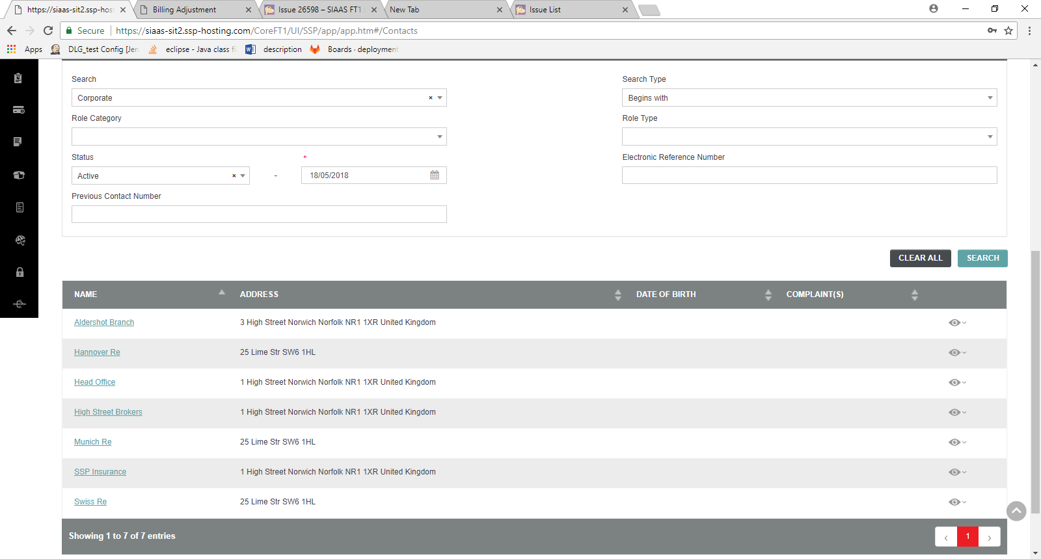

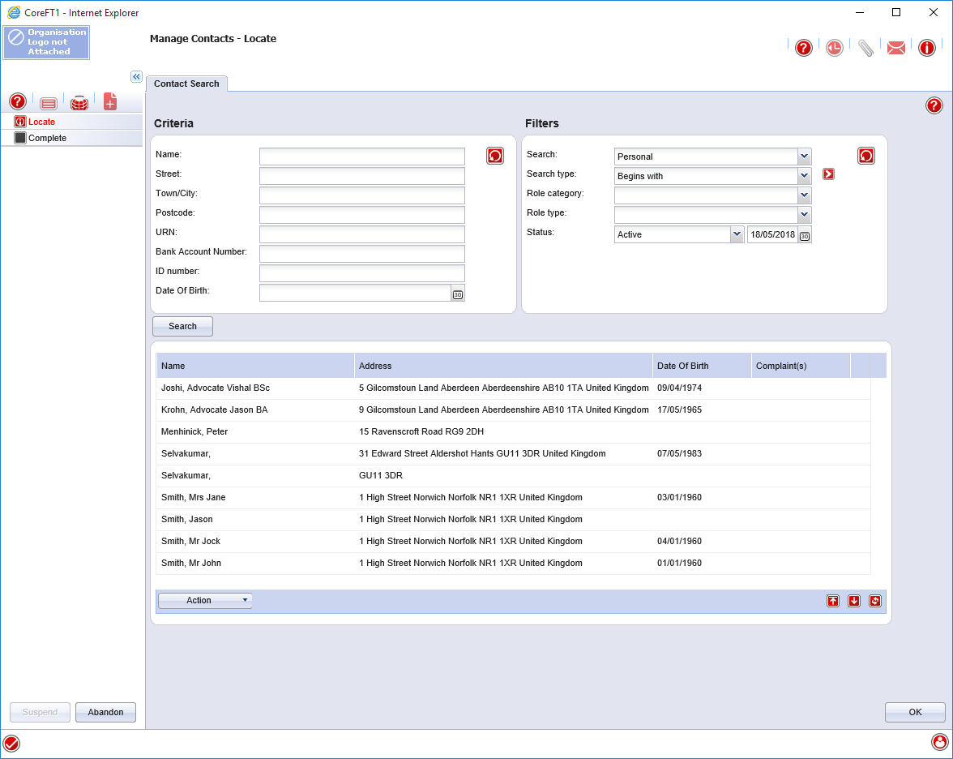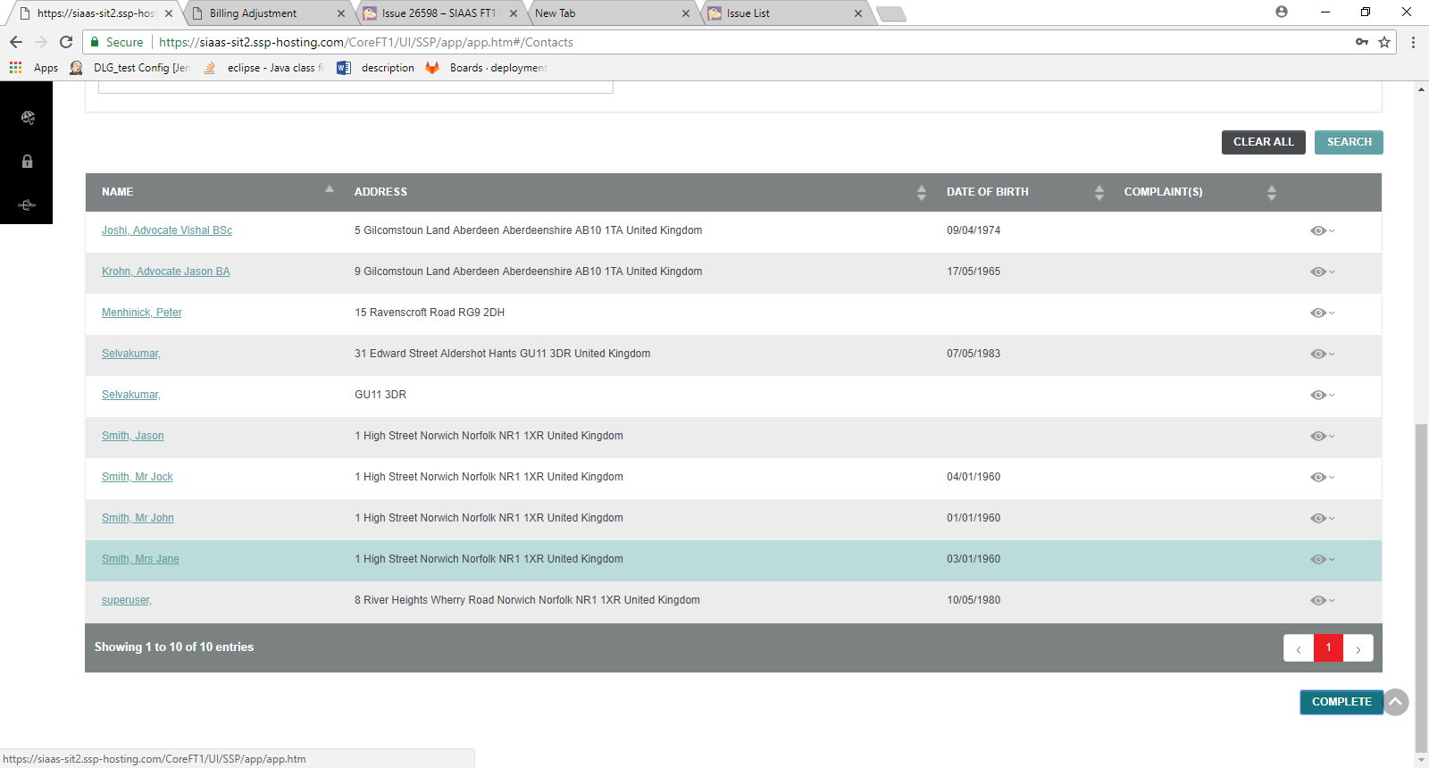

TC -37 Verify Complete button -Pass



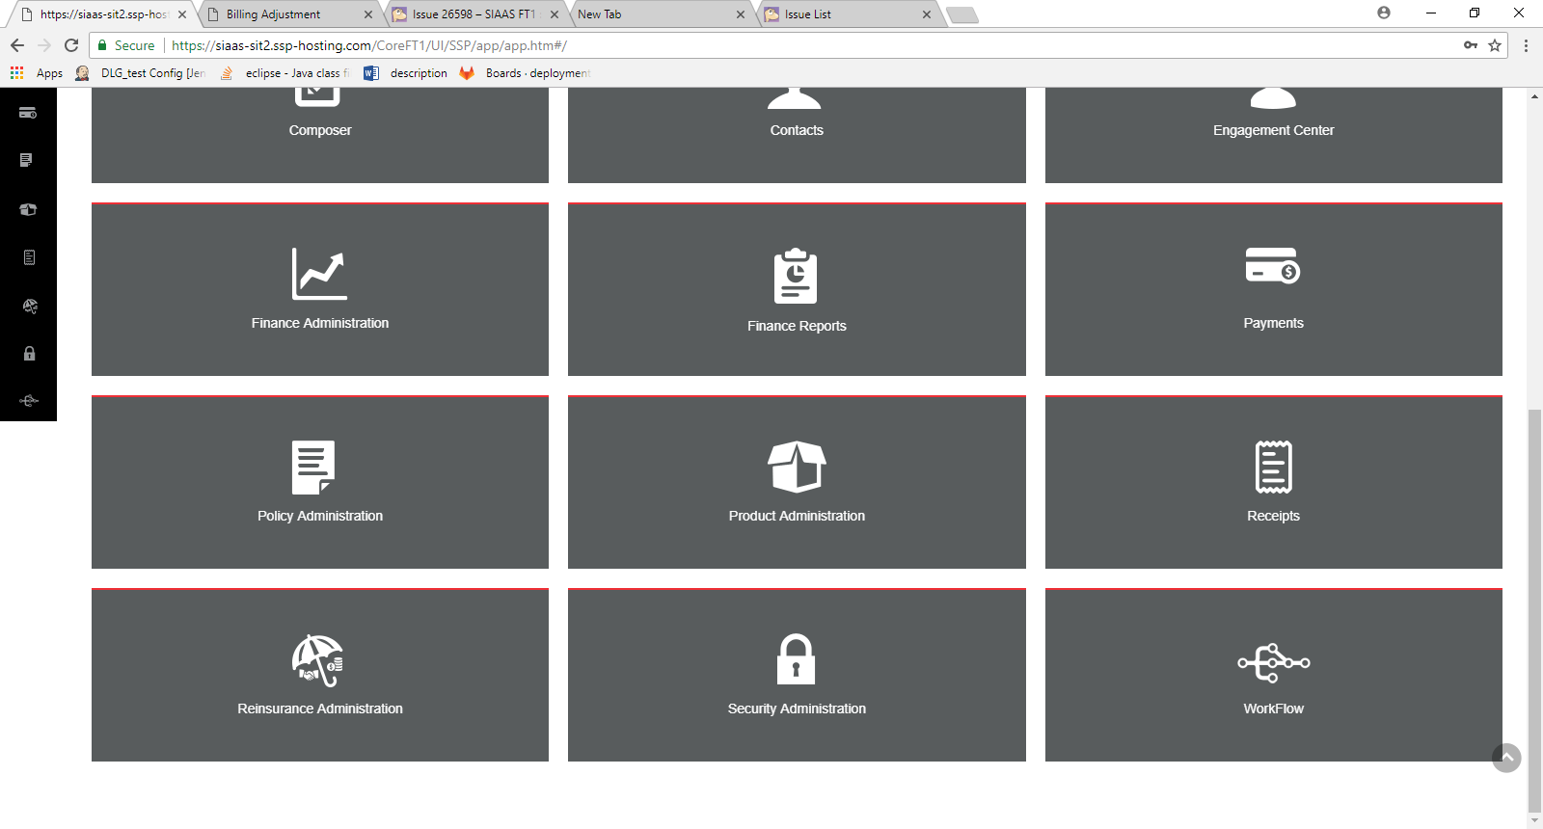

TC -38 -Verify search results –Pass

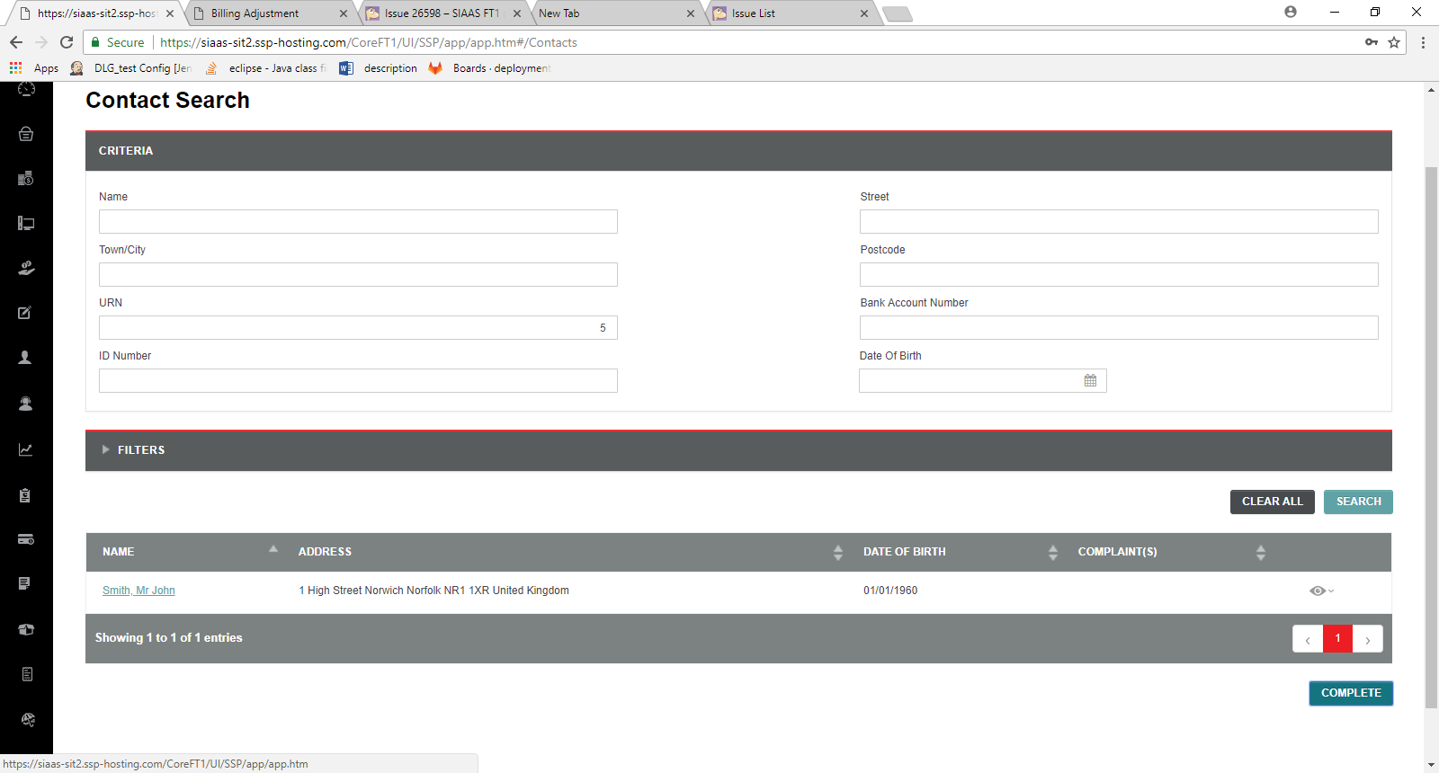

TC – 39- Verify the Role Category dropdown values –Pass

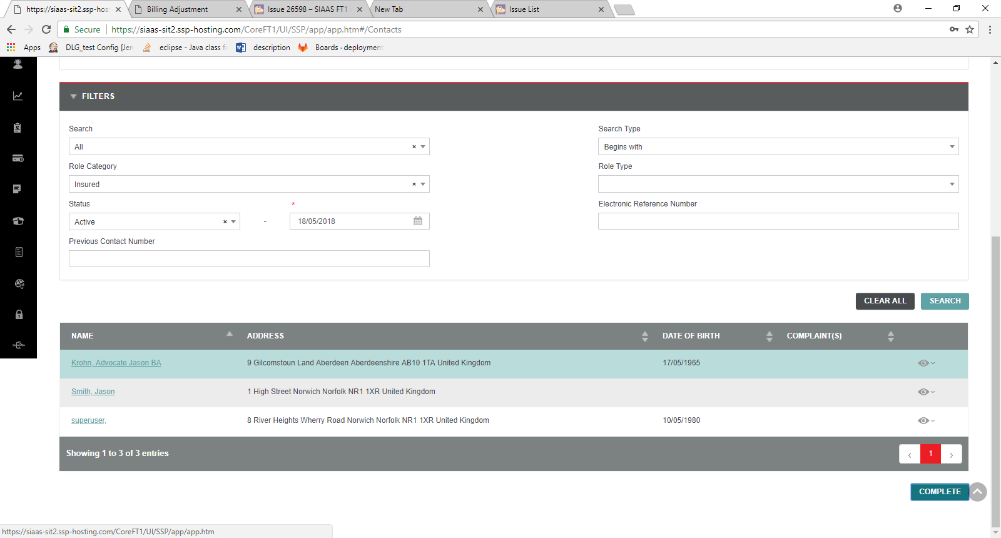

TC – 40 - Verify the Role Category dropdown values –need to check

TC – 41 - Contact Search - Verify the status list box values -Pass

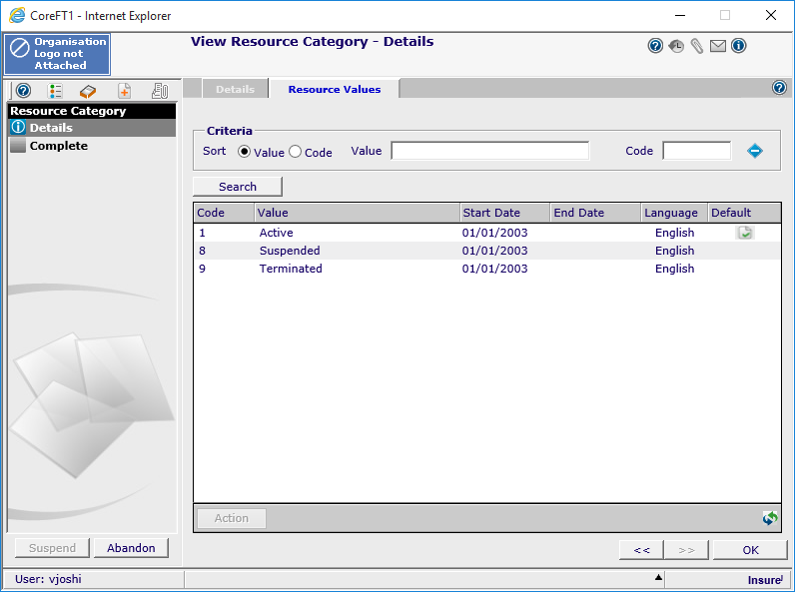

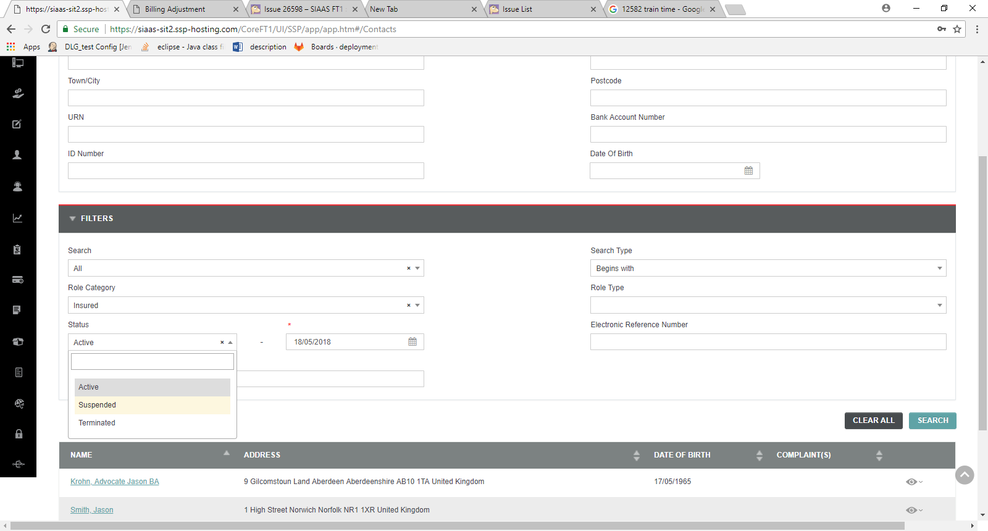

TC – 42 - Contact Search - Verify the breadcrumb

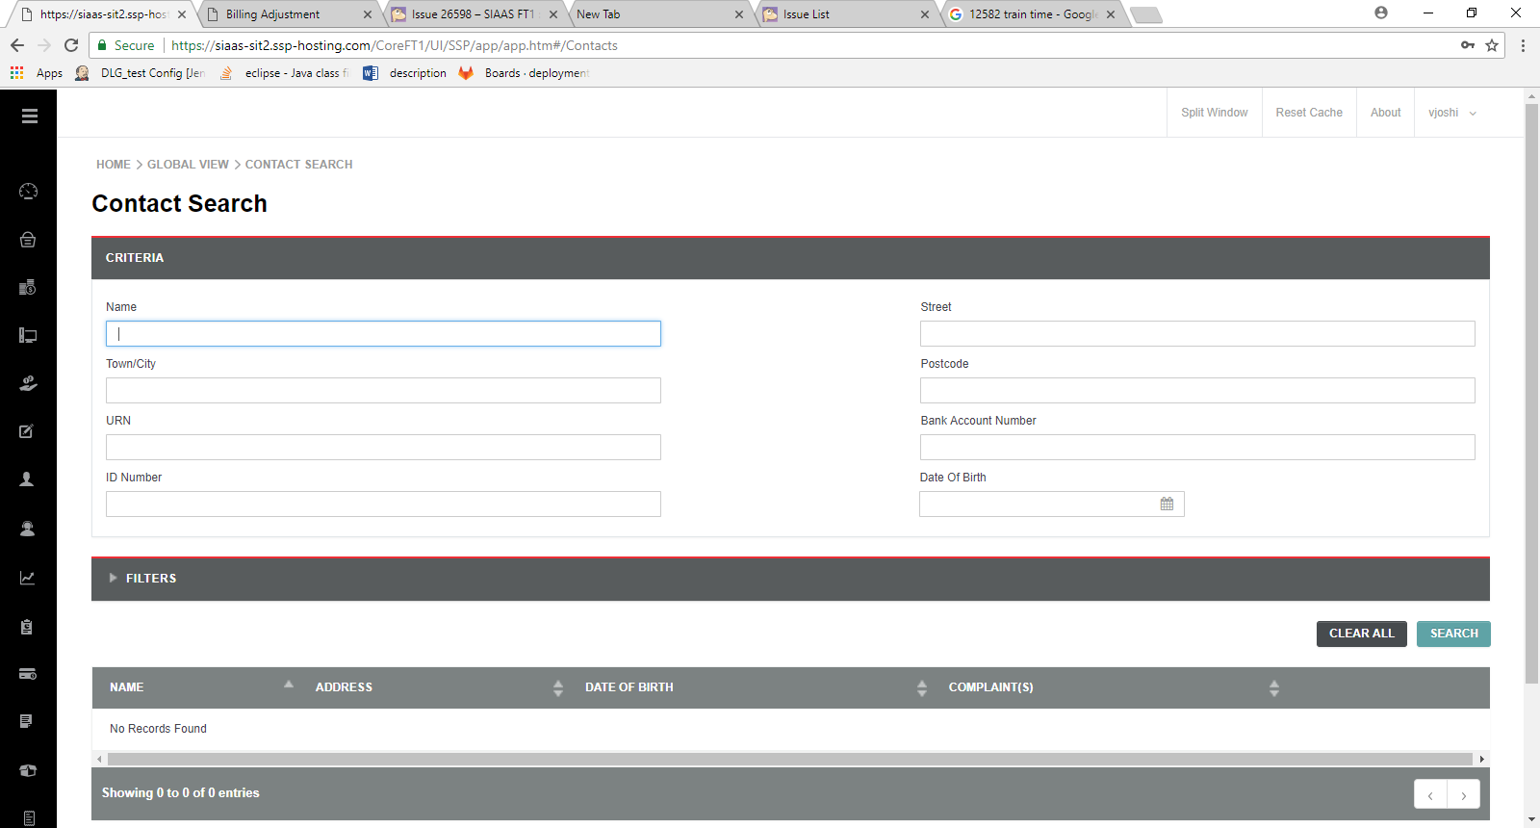

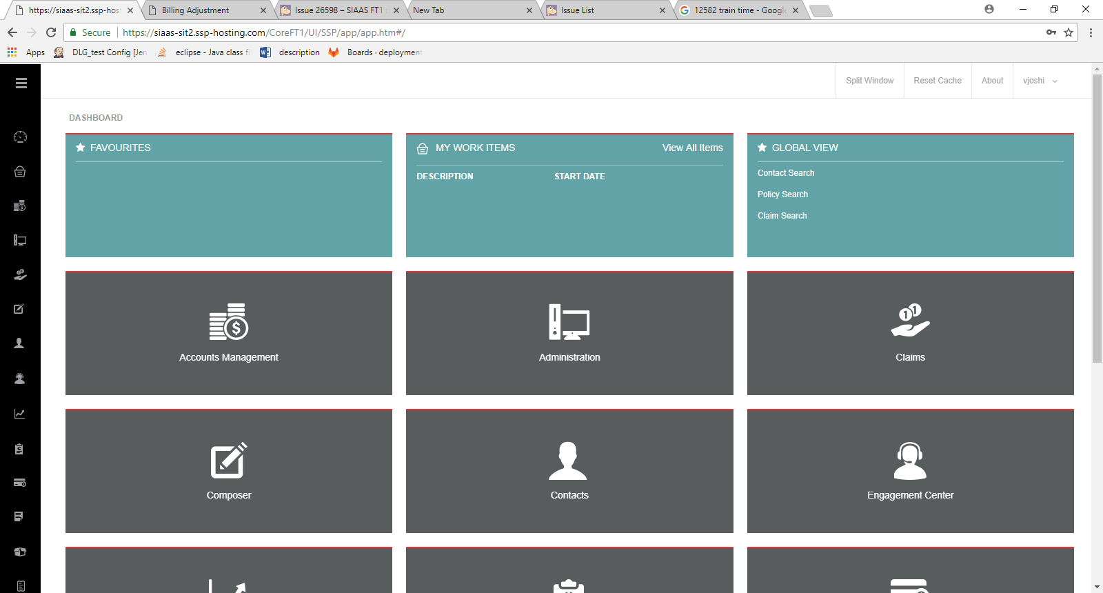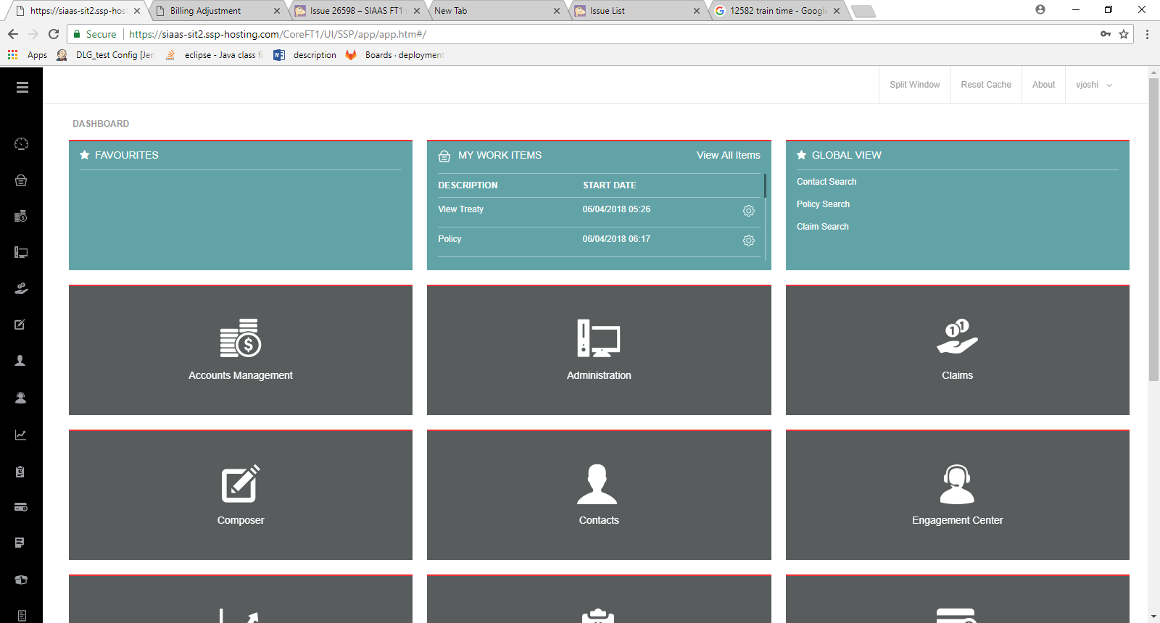

TC – 43- Verify the view link from the contacts list- Pass

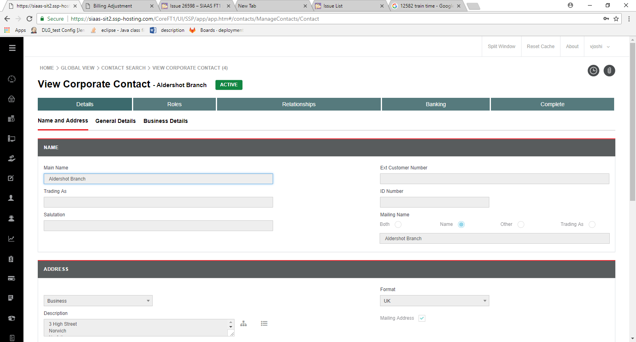

TC -44 Verify the Contact Details in top of the view page -Pass

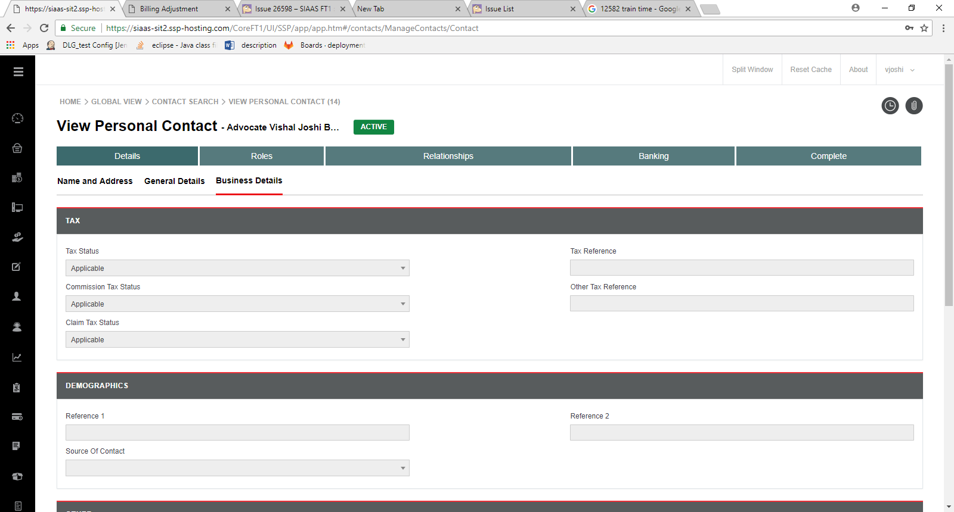

TC -44 Verify the Contact Details in top of the view page -pass

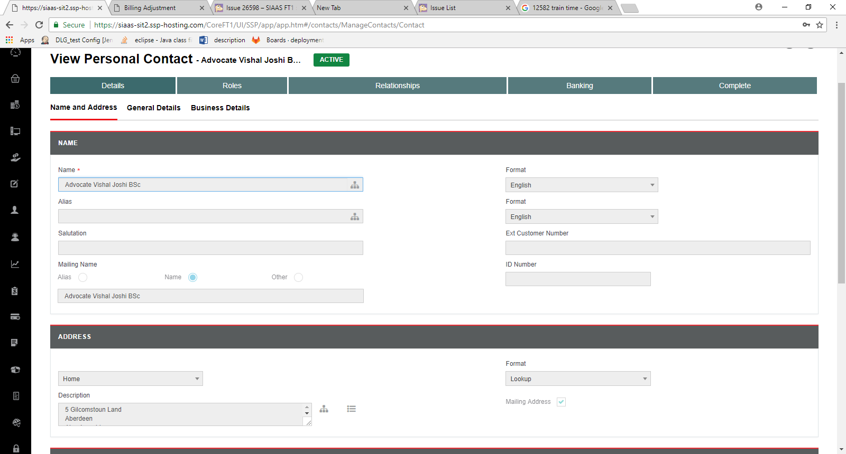

TC – 45 Verify the View page contains three tabs pass

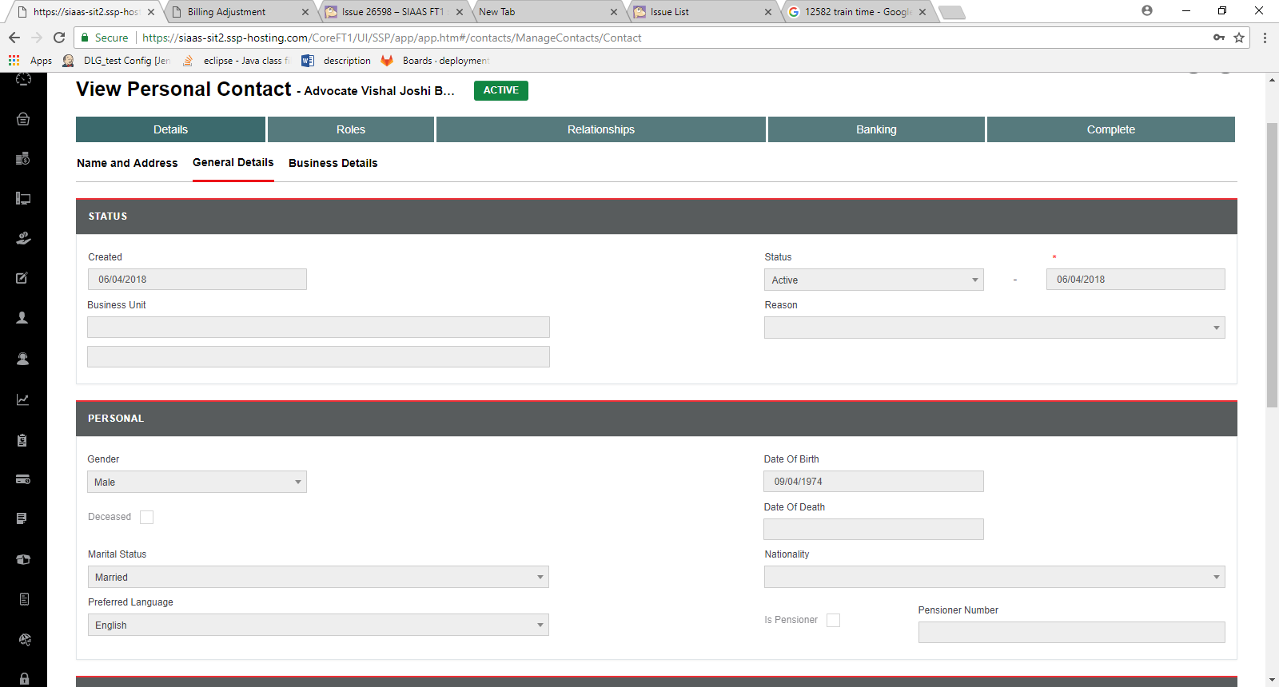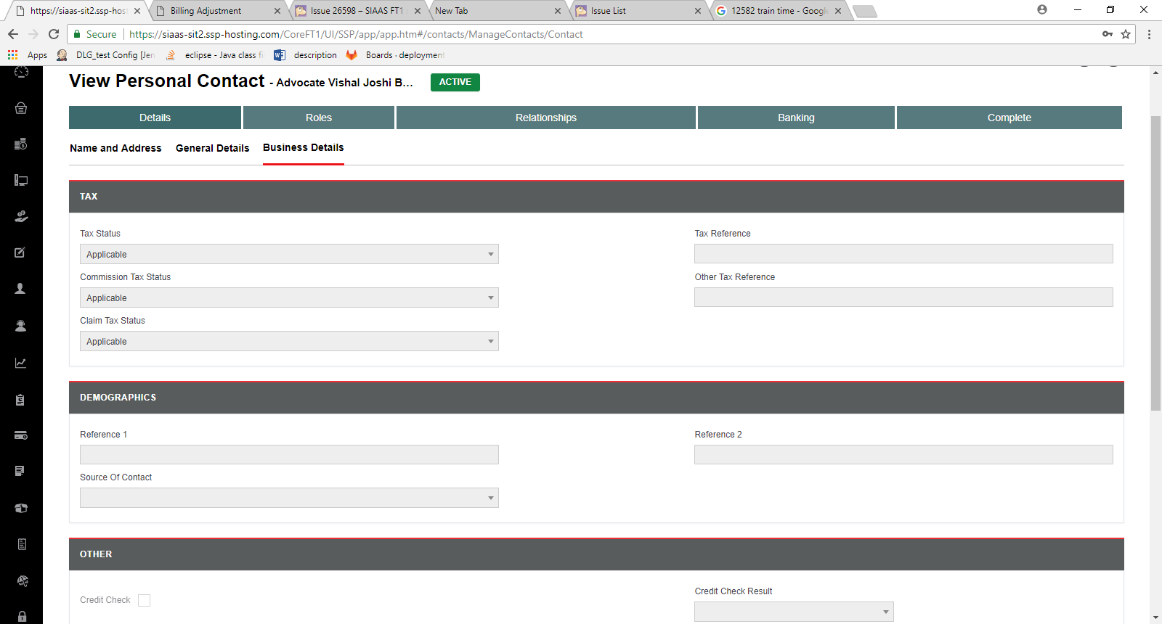

TC – 46 -Verify the View page fields and buttons in Name and Address Tab

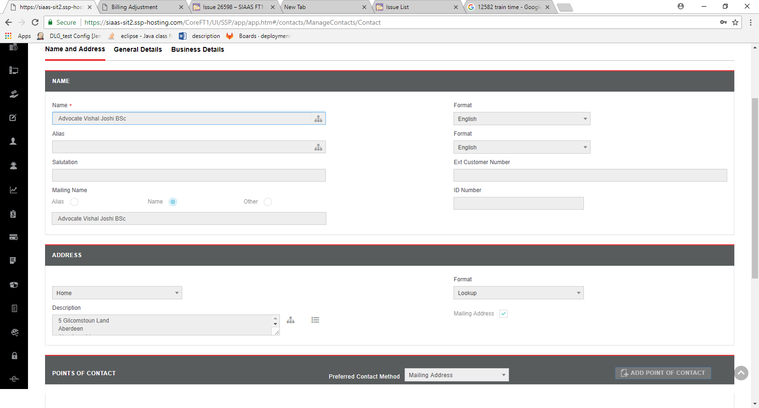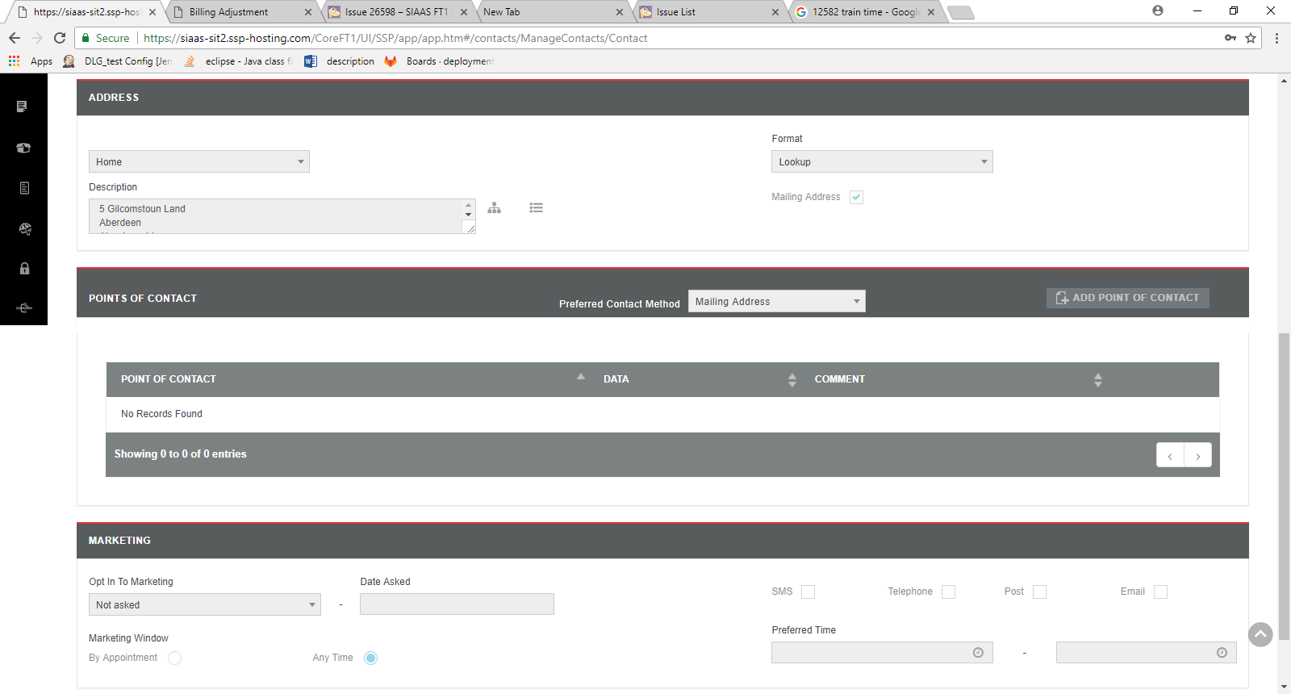

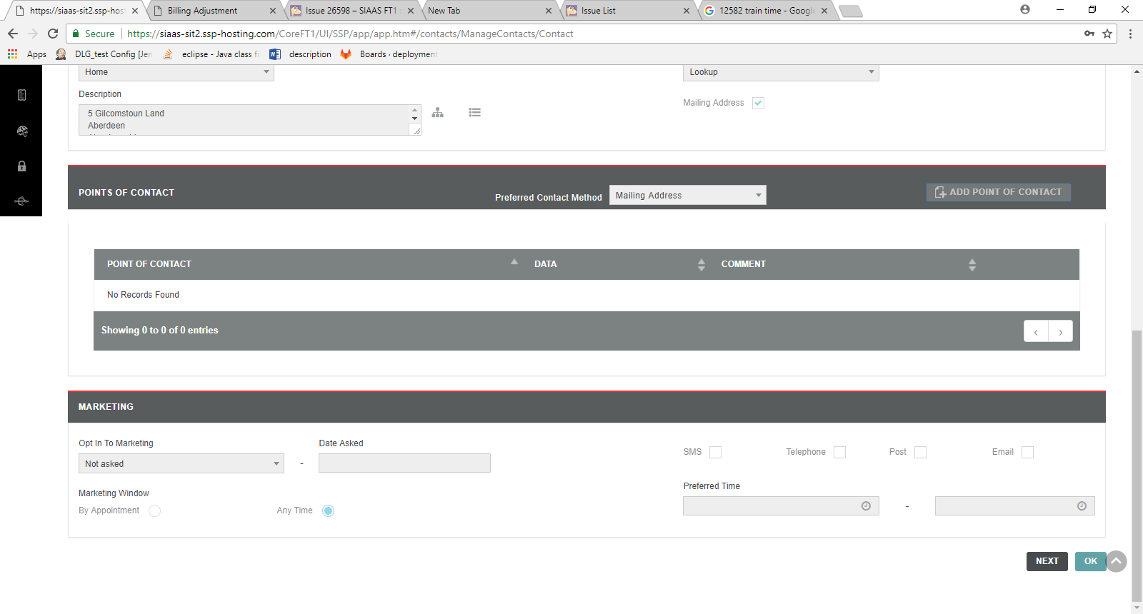

TC -47 -Verify the fields and buttons in Address In Parts pop up window of Name and Address Tab

TC – 48 - Verify the fields and buttons in Address List pop up window of Name and Address Tab

TC -49 - Verify the column header titles and buttons in Points of Contact block -Pass